**Testing this Year’s New Tools- Yes, TOOLS!!**

publication

**VEGAS**

**2003**

**RECAP!!**

**(pg-12)**

: <-

**’• •** 1**;•. ALOA Lands in the**

**Desert Sands!**

Runnln* Rebel® and  
New Business Models  
*- u Fast-Crowing

u»» Wo0 ouru*=

„ _ — y«-*^T^.n -***

**v. 1**

rco t»ekrfisrcp*

—-

**;** 1 ! **»'«• '». :#A- • \***

* % * hi >>\V|‘*vV\*»Vt!

I 4 t v 3w'K\*Yd

- Jer**

\ *>» v .Vt'TOvYv

**. ......**

- ■ >:* • ZZZSZZm.

*- .v

\

**4-**

ST', * ■> . * > * ^

; ; •

**;|li**

*V

i « ■ .* .,,,. v:% ;*'? '. , , ■ - ;' " . •

*•■■■■■'■ *

*•

;• . - * — J'^'sL * * : ••

**^ ■■ - •■ • - -, ' v , **» ' ?•'** ■'-••■ \***

-

*******************3-DiQ[Y 3Q3

Breck H. Camp CML PO Box 47070 Atlanta GA 30362-0070

**IiiIIiIIiiiiiIIiiIIiiii** Mil llllllllllllllllllllll lllmul.ll

Plus:

Impressioning Series (Part 2),  
the 2003 Kia Spectra, a tricky  
Victor Safe and More!

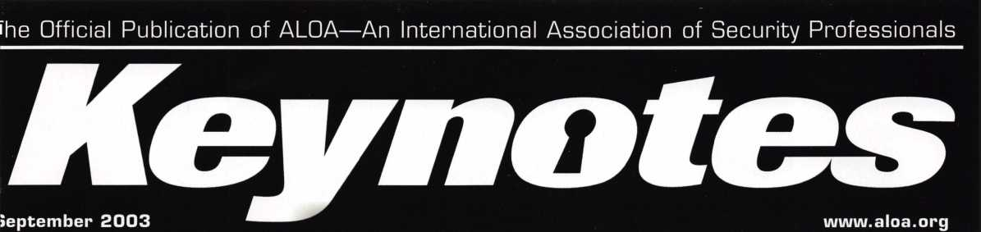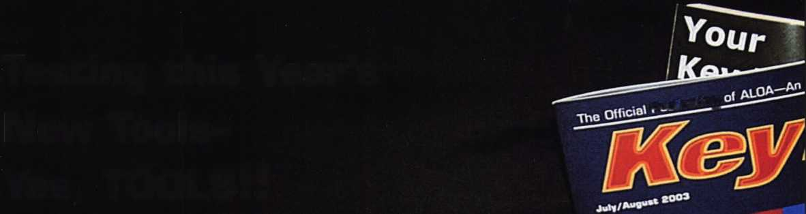

**MEMBERSHIP APPLICATION**

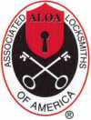

Welcome to the Associated Locksmiths of America, Inc., an association for persons involved in the security industry as  
locksmiths, security consultants, educators, manufacturers and distributors.

To apply for membership, please complete this application and submit it with the dues for the current year, and your  
business card, company letterhead, or other suitable proof of employment.

All of the following questions MUST be answered before this application may be processed. Please type or print.

TYPE OF MEMBERSHIP

Please check only one.

* ACTIVE MEMBERSHIP Individuals actively engaged in supplying, servicing, or installing security hardware for a period of not less than two years.
* APPRENTICE MEMBERSHIP Individuals who are in initial train­ing and meet all the requirements for Active Membership except for the length of time in the security industry.
* ALLIED MEMBERSHIP Individuals whose position in the security industry relates to the aims, policies and promotion of the locksmith and his/her craft.

APPLICATION AND FEES

A $40 application fee, appropriate annual dues, and your business card, company letterhead, or suit­able proof of employment must accompany this application. Your second year's dues will be prorated based on the date your application was received by ALOA.

FINAL CHECKLIST

|  |  |
| --- | --- |
|  | U.S.  Dollars |
| □ Application Fee | 40.00 |
| ANNUAL DUES |  |
| □ Active/Allied Member | 1 30.00 |
| □ Apprentice Member | 80.00 |
| OTHER FEES |  |
| □ Canadian Air Mail | 20.00 |
| □ Overseas Air Mail | 50.00 |
| Total Enclosed |  |

**Return to**

**ALOA**

**3003 Live Oak Street  
Dallas, TX 75204-6185  
(214)827-1701**

CANDIDATE (PLEASE TYPE OR PRINT)

|  |  |  |  |
| --- | --- | --- | --- |
| Name □ Mr. □ Mrs. □ Ms. | | | |
| Business Name | | | |
| Mailing Address | | | |
| City | State | Zip Code | Country |
| Work Phone | Home Phone |  | Fax |
| Email Address | Website |  |  |
| Date of Birth | Social Security Number |  |  |
| Directory Address (if different than | mailing address) |  |  |
| City | State | Zip Code | Country |

□ Do Not List in Directory

PROFESSIONAL INFORMATION

1. Are you a...

* Sole Owner □ Corporate Officer
* Partner □ Employee □ Student

1. Are you currently employed in the security industry?

O no O yes, years

1. How did you learn locksmithing or security work?

4. ALOA Sponsor

Sponsors ALOA Number

Please note, if you are sponsored by an ALOA member, your application will be immediately processed with a 90-day probation period. Otherwise, final processing takes up to 120 days.

5. Names and addresses of two industry-relat­ed references (required):

Nome

*Address*

*Name*

*Address*

6. IMPORTANT: Have you ever been convicted of a felony? O No □ Yes

If yes, please give details on a separate sheet. All felonies are reported to the Membership Department for review.

METHOD OF PAYMENT

□ Check □ MasterCard □ Visa □ Discover □ American Express

|  |  |
| --- | --- |
| Card Number | Expiration Date |
| Please print name as it appears on card |  |

Cardholder's Signature

I certify that all statements are true and, if accepted as a member, I agree to abide by the rules, regulations, and Bylaws of ALOA, and further agree to  
adopt the Code of Ethics of ALOA as my own, and adhere to it to the best of my ability. Should my membership be discontinued, I agree to return my mem-  
bership card, and cease use of all ALOA insignia.

Signature

01/01/2002

Date

**Illuminate**

Your Future

Join us next summer at the East Coast's premiere travel destination as we set the stage for the biggest security event in the world. Come to Baltimore and discover classes, workshops, and exhibits that will help you shine in today's marketplace.

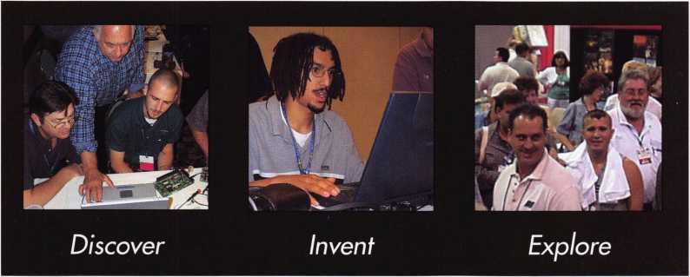

fe^UTtWORE, Ml?

*get it*... *together*

The ALOA Convention and Security Expo • Baltimore Convention Center • July 19-25, 2004 • (800)532-ALOA(2562)

[convention@aloa.org](mailto:convention@aloa.org) • [www.aloa.org](http://www.aloa.org)

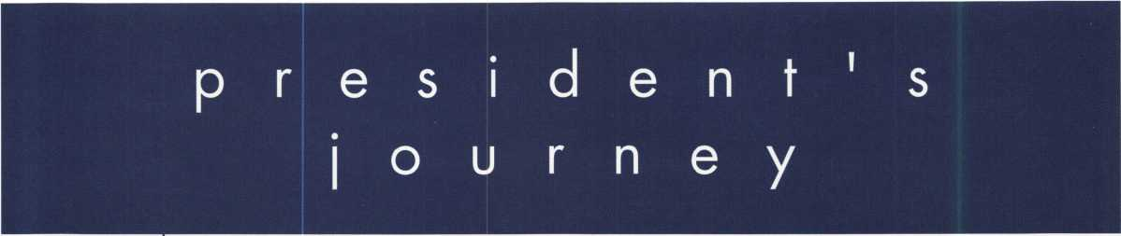

It is a pleasure to be writing my first installment of "Presidential Pennings." I am still reeling from a fantastic convention in Las Vegas. By all accounts, it was a tremendous show! The trade show was phenomenal and was well attended all three days! A special commendation goes out to Joanne Mims, our Convention Man­ager, as this was her first ALOA trade show ... start to finish. She did a fantastic job, as did the rest of the ALOA staff! The convention is a staff function, and Bill Gibson, staff, and our volunteers, all did a tremen­dous job!

My first official function as ALOA President is to welcome my Board of Directors! I am very fortunate to wel­come back Gordon Racine and Julie McLuney, representing the Southwest Region, and Mark Blum and John Soderland in the North Central Region. We have two new directors in the Southeast, Tom Gillingham from Nashville, TN, and Ken Kupferman from Tampa, FL. I am expecting big things from them. I am also pleased to announce that I am appointing Tom Lynch as a non-voting director from the Northeast Region.

Tom brings the unique perspective of locksmith, instructor, inventor and distributor with him, as well as some great marketing ideas.

Those who did not attend the convention did not see the efforts of John Dorsey of Eau Claire, Wl. John is striving hard to get President Bush to declare Oct. 6, 2003, Professional Locksmiths Day. John worked the convention floor to get petitions signed in support of this declaration, the first Monday of National Crime Pre­vention Month. This is the kind of public awareness that we as an industry need, and I commend his efforts. Those who were not at the membership meeting, also missed an overview of the plan submitted by Hans Mejlshede, for ALOA shop certification. Much more about this will be presented in future issues of Keynotes.

I have called my first Board Meeting for Oct. 16-17, 2003, at the Holiday Inn at the Portland, OR Airport. The Pacific Locksmith Association was gracious enough to invite the ALOA Board to hold its meeting in con­junction with its Security Conference, which is October 14-1 8. The meetings are open to all ALOA mem­bers, and I encourage all members to attend and participate when we are in your area.

We are here to serve you!

Respectfully,

William L. Young, CML

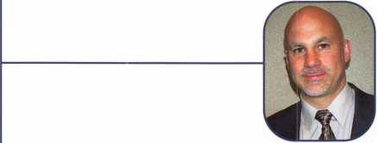

Keynotes • September 2003



**jSEEJ**

***Visit our Website on****[www.stamcctv.com](http://www.stamcctv.com)*

**THE COMPLETE**

**CCTV PROGRAM ON CD-ROM  
FOR STAFF TRAINING AND  
PRODUCTIVITY ENHANCEMEN**

STAM **Insight** has been  
developed to enhance CCTV  
skills and productivity with  
many different uses.

Productivity

Hi System Drawing t# Estimation # CCTV Training HI CCTV Reference **HI** Sales/Demo **HI** System Design 1# Staff Evaluation

10 hours

14 hours

Estimation

**INFOMATE**

**WORKMATE**

**ULTIMATE**

CCTV Content

*CCTV Calculators* Demonstration Tool

Drawing Internet Enabled

Pre-Test

**Sold in Over 50 Countries**

Distributed by:

3003 Live Oak Street  
Dal las, Texas 75204



■ Yes, please send me a FREE PREVIEW CD ROM $9.95 S/H

Name:

Job Title:

Organization:

Address:

Country Tel: (

.Zip/Postcode, .e-mail

Fax: ( )

COPYRIGHT © 1996 Security Training and Marketing Pty Ltd. All rights reserved ACN 057 006 541

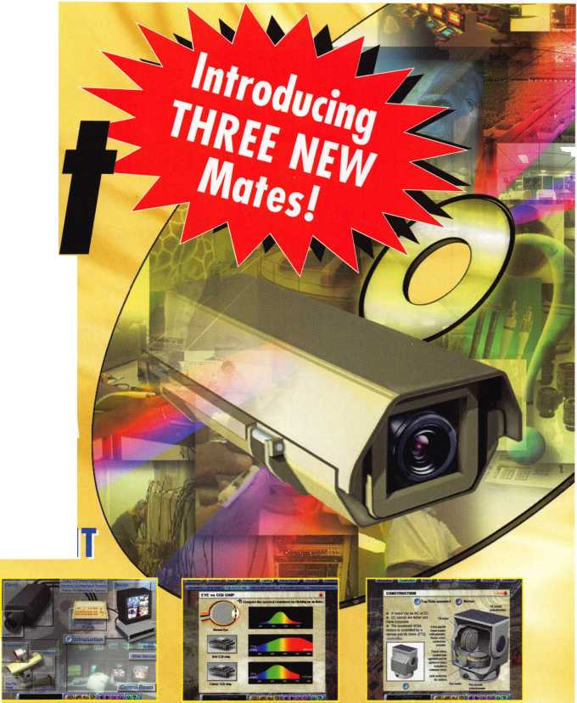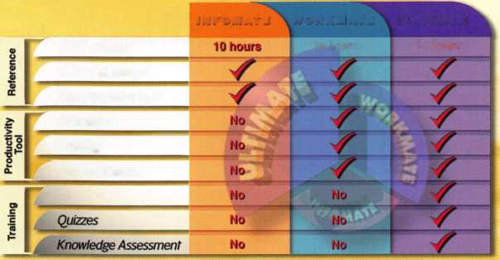

t

u

r

e

s

**D3 VEGAS '03 RECAP** By Jim DeSimone, Keynotes Editor

Get the scoop on one of the best ALOA shows in history!

**18**

TOOL PARADE!

ALOA SHOW STANDOUTS THAT SAVE

**TIME AND MONEY** By Greg Perry, CML, CPS

This year's ALOA show in Las Vegas was outstanding. The venders did an  
excellent job of showing off both their new products as well as their existing  
product lines. I wanted to highlight some of the new products available that  
are new and/or improved.



Basic Impressioning, Part 2: Techniques **By Jim Hancock, CRL**

Now with the proper tools in hand, we are ready to start impressioning.

Inside the 2003 KIA SPECTRA **By Jeff Trepanier, RL**

An interesting little sedan, the car is proudly described by its makers as, "a car  
that looks sporty, but acts responsibly." Let's take a look and see how responsi-  
bly the locks on the car work.

Tuning Up a VINTAGE VICTOR **By Greg Perry, CML, CPS**

Victor Safe Company founded in 1 885 was one of the larger cast-iron fire  
safe companies; they continued to produce safes (according to Carl Cloud)  
until 1917, when Mosler purchased them. In addition to cast-iron fire safes,  
they also produced pressed-steel fire safes, cannonballs, jeweler's chests and  
vault doors. Inside the safes were original guarantee certificates along with  
service cards that show a picture of the factory with the claim, "The Largest  
Fire-Proof Safe Works in the World." Let's take a look at one.

departments

|  |  |  |  |
| --- | --- | --- | --- |
| Executive | 5 | Legislative |  |
| Applicants | 6 | Update | 38 |
| Calendar | 8 | Classifieds | 40 |
| Core | 10 | Associate |  |
|  |  | Members | 42 |
|  |  | Back Page | 44 |
| it our | w e b s i | i t e at w w | w . |

O r g



executive

Volume 49, Issue 8

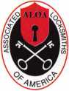

Additional contact information for the ALOA Board and most Keynotes authors is  
available through "Locksmith Search'" on the ALOA Web site- [www.aloa.org](http://www.aloa.org) or by  
contacting the ALOA office at 3003 Live Oak Street; Dallas, TX 75204; (800)532-2562;  
FAX (214)827-1810; e-mail [aloa@aloa.org](mailto:aloa@aloa.org).

|  |  |
| --- | --- |
| Editor  Jim DeSimone | [editor@aloa.org](mailto:editor@aloa.org) |
| Technical Editor  David Lowell, CML, CMST .... | [david@aloa.org](mailto:david@aloa.org) |
| Editorial Advisor  John D. Cannon, CML | .[jdcannon@worldnet.att.net](mailto:jdcannon@worldnet.att.net) |
| Art Director  Betty Henderson | [betty@aloa.org](mailto:betty@aloa.org) |
| Advertising Sales  Kim Hammond | voice: 817-645-6778  Fax: 817-645-7599 e-mail: [adsales@aloa.org](mailto:adsales@aloa.org) |
| Executive Director  Charles W. Gibson, Jr., CAE | [charlie@aloa.org](mailto:charlie@aloa.org) |
| Convention & Meetings Manager  Jo Anne Mims [joanne@aloa.org](mailto:joanne@aloa.org) | |

PRP/Education Manager

David Lowell, CML, CMST [david@aloa.org](mailto:david@aloa.org)

Operations/Membership Manager

Mary May [mary@aloa.org](mailto:mary@aloa.org)

Government Relations Manager

|  |  |
| --- | --- |
| Paul Kanitra | [paul@aloa.org](mailto:paul@aloa.org) |
| IT Operations Manager  Greg Jackson | [greg@aloa.org](mailto:greg@aloa.org) |
| Comptroller | Kathy J. Romo |
| Membership Coordinator | Shelly Jett |
| Convention & Meetings Assistant Karen Lyons | |
| PRP/Education Coordinator | ... Esperanza Rodriguez |
| Accounting Coordinator | Stephanie Brothers |
| Mail Room Coordinator | Shawn Alvear |

Receptionist

Kevin Wesley

Contributors

Jerome Andrews, CML  
Paul Chandler, CRL  
Claire Cohen, CML  
Brian Costley, CML, CMST  
Eric Costley, CRL

Ray D'Adamo, CML Sal Dulcamaro, CML Billy Edwards, CML Dan Graffeo, CRL,CMST Jim Hancock, CRL

AJ. Hoffman, CML Jeff Nunberg, CML, CMST Randy Simpson, CML Robert Stafford, CML Dave Thielen, CML

Greg Perry, CML,CPS Tom Seroogy Charles Stephenson, CPS Dennis Watanabe, CML, CMST

**Mission Statement:** The Associated Locksmiths of America, Inc. is dedicated to enhancing the professionalism, education and ethics among locksmiths and those in related sectors of the physical security industry. With approximately 10,000 members in the United States, Canada and the freeworld, ALOA is poised to help members obtain the knowledge, the strength, and the confidence to perform their role in the physical security field with pride and dignity. But it is only through active involvement and participation that ALOA can fully achieve its potential—and can help members to achieve theirs.

**Policies: Keynotes**® is the official publication of the Associated Locksmiths of America, Inc. (ALOA). **Keynotes**1® acts as a moderator without approving, disapproving, or guaranteeing the validity or accuracy of any data, claim, or opinion appearing under a byline or obtained or quoted from an acknowl­edged source. The opinions expressed by the authors do not necessarily reflect the official views of ALOA. Also, appearance of advertisements and new products or service information does not constitute an endorsement of products or services featured by the Association. The Association does not accept responsibility for the inaccuracy of any data, claim, or opinion appearing in this publication, due to typographical errors on the part of the authors, Association staff or its agents.

**Editor's Note:** This publication is designed to provide accurate and authoritative information in regard to the subject matter covered. It is provided and disseminated with the understanding that the publisher is not engaged in rendering legal or other professional services. If legal advice and other expert assistance is required, the services of a competent professional should be sought.

**Authors' Payment:** Payment for eligible submissions to Keynotes will be based on the following criteria: topic, time spent and past contributions. Authors who regularly submit to **Keynotes®** are generally paid a higher rate. The latter is especially true of authors who write to fit specific editorial needs and submit said copy by **Keynotes**® deadlines. As a general guideline: Average payment for a 750 word, business or 'light' technical article would be $200. Payment for a 1500 word article involving significantly higher time and research efforts would be $400.

Payment will not be offered for articles submitted by ALOA employees or members of the ALOA Board of Directors (unless material is of a technical nature), nor for articles submitted by a company that promote that company's products or services. ALOA reserves the right not to pay for articles sub­mitted by an individual(s) that promote a particular company's products or services.

**Disclaimer:** The Associated Locksmiths of America, Inc., (ALOA), reserves the right to refuse any article for any reason. Additionally, ALOA reserves the right to edit, amend or modify any article submitted for publication in order to preserve technical accuracy, clarity, fairness or grammatical cor­rectness. ALOA will make the best efforts to notify the author of any changes. The extent of ALOA's liability for any article or information contained therein will be a notice of correction or retraction in the next possible issue.

**Keynotes**® (ISSN 0277 0792) is published monthly except for the combined June/July issue by The Associated Locksmiths of America, Inc., 3003 Live Oak St., Dallas, TX 75204-6186. Telephone: (214) 827-1701; FAX (214) 827-1810; e-mail [aloa@aloa.org](mailto:aloa@aloa.org). Subscription rates for members—$15.00 per year. Business class postage paid at Dallas, Texas. POSTMASTER: Send address changes to: Keynotes, 3003 Live Oak St., Dallas, TX 75204-6186. © Copyright 2003, All rights reserved. No part of the contents may be reproduced or reprinted in any form without prior written permission of the publisher.

President

: William L. Young, CML [president@aloa.org](mailto:president@aloa.org)

Secretary

John D. Cannon, CML  
(703)960-6413  
secretary@aloa .org

Directors, Northeast

Robert E. Mock  
(856)863-0710  
[nedirector@aloa.org](mailto:nedirector@aloa.org)

Peter Saraiiian, CRL  
(973)890-9797  
[nedirector@aba.org](mailto:nedirector@aba.org)

William L. Young, CML  
(610) 647-5042  
ned irector@aloa .org

Directors, Southeast

Tom Gillingham, Jr.,:CML, CPS  
(615)812-5625  
sed i rector@a loa. org

Ken Kupferman, CPL  
(813)961-5784  
[sedirector@aloa.org](mailto:sedirector@aloa.org)

Directors, North Central

Mark E. Blum, CML, CPS : (517)482-5809

[ncdirector@aloa.org](mailto:ncdirector@aloa.org)

John Soderland, CML, CMST  
(414) 327-5625  
[prolock@aloa.com](mailto:prolock@aloa.com)

Director, South Central

CD Lipscomb, CML, CPS  
(903)874-3522  
[scdtrector@aloa.org](mailto:scdtrector@aloa.org)

Directors, Southwest

Gordon R. Racine, CML  
(719) 384-4707  
swdirector@aloa .org

Julie McCluney, CRL : (714)636-5652

[swdirector@aloa.org](mailto:swdirector@aloa.org)

Director, Northwest

Scott L. Henke, CPL, CPS  
(907) 248-3785  
nwdi rector@aloa .org

Director, European

Hans Mejlshede, CML  
(453)539-3939  
[eurdirector@aloa.org](mailto:eurdirector@aloa.org)

Director, Asian

JoeJ. Lee, CRL  
(215)289-2404  
[asiandirector@aba.org](mailto:asiandirector@aba.org)

Director, Associate

Paul M. Justen (800)333-6953 . [asdirector@aloa.org](mailto:asdirector@aloa.org)

Trustees

/ [trustees@aioa.org](mailto:trustees@aioa.org)

Randy Simpson, CML  
(281)240-5959

JohnJ. Greenan, CML, CPS  
(773) 486.2030

Dallas Brooks  
(334) 826-8990

Past Presidents

2001-2002 Randy Simpson, CML 1999-2001 John Greenan, CML, CPS 1997-1999 Dallas C. Brooks 1995-1997 David Lowell, CML, CMST 1993-1995 Breck Camp, CML 1991-1993 Henry Prtnfz, CML 1989-1991 Evelyn Wersonick, CML, CPS 1987-1989 Leonard Passareilo, CPL 1985-1987 Joe Jackman, CML 1983-1985 Stanley Haney, CPL 1981-1983 Louis LaGreco, CPL 1979-1981 John Kerr, RL 1977-1979 Clifford Cox, CML 1974-1977 Charles Hetherington 1972-1974 Gene Laughridge 1970-1972 William Dutcher, RL 1968-1970 Constant Maffey, Rl 1966-1968 Harold Edelsfein, Rl 1964-1966 William Meacham 1962-1964 Robert Rockliffe, CPL/ 1960-1962 Edwin Toepfer, RL 1956-1960 Ernest Johannesen



Keynotes • September 2003

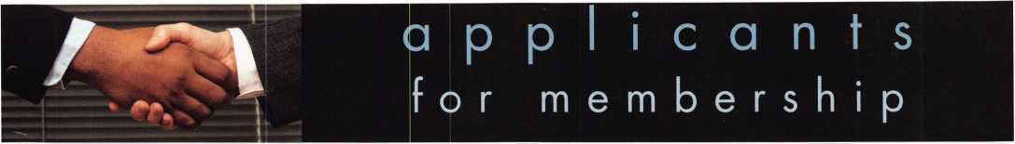

|  |  |  |  |  |  |  |
| --- | --- | --- | --- | --- | --- | --- |
| AK |  | FL | Olney | PA |  | ON |

**Anchorage**

Nathan Damario Josh Varady

**AL**

**Foley**

Robert E. Gardner III

**Hartford**

Dallas L. Watson III

**Mobile**

William Vickery

**Gainesville**

Kenneth Gotay

Sponsor: Leonard P. Solt

**Melbourne**

Debora Palmer

**Pace**

Mark C. Gaydosh

**Sarasota**

Daniel Crawford

Sponsor: James B. Kruysman CPL

**GA**

David L. Griffin

Sponsor: Robert D. DeWeese CML

**Waldorf**

Charles R. Atkins Jr

**Grand Blanc**

Andrew Tenneriello

umo

**Columbia**

Richard McMiller

**Bernville**

James D. Fox

**PR**

**San Juan**

Reinaldo A. Valenzula

Sponsor: Gilberto L. Valenzuela RL

**SC**

**Summerville**

Tadd Murray

**Markham**

Andy Douse

Sponsor: John W. Rowland CML

**Richmond**

Wayne Duggan

Sponsor: Darrell J. Wilchynski



**Durham**

Martin Young Erith Kent Marcus Brocker

**AZ**

**Bullhead City**

Jeff Jochens

**Conyers**

D Steven Wilhite

Sponsor: Marcus A. Wilhite

**Stockton**

Clifford W. Short

**MS**

**TN**

**Memphis**

Jason Carter

**Germany**

**Ham berg**

Mahmod Abu Shanab

**Phoenix**

Wayne R. Stuart

**Sedona**

Ben LaMere William Thompson

**Youngtown**

Wesly Womack

**CA**

**Berkeley**

Victoria Cruz

**Camarillo**

Bruce D. Ferguson

**Inglewood**

Jorge Quinones

**Long Beach**

Rene' I. Lopez Efrain Barajas

**Los Angeles**

Zion Hafuta

**Orangevale**

Brian M. Johnson

**Palo Alto**

Frederick P. Collier Paso Robles David P. Faber

**Rosamond**

Timothy M. Lozano

**Salinas**

Wayne Hidaka

**San Bernardino**

Ray P. Hively

**San Diego**

Gerry L. Buckhanon

**CO**

**Cumming**

Suzette Davis

Sponsor: John C. Elliott Jr, CML, CPS

Alex K. Davis

Sponsor: John C. Elliott Jr, CML, CPS **Decatur**

Marvin L. Beasley

**Lilburn**

Arthur J. Maddalena

**ID**

**Boise**

Jeremy Reeder

**IL**

**Minooka**

Steve A. Thornton

Sponsor: William T. Beranek

**IN**

**Elkhart**

Paul L Tucker

**Florence**

Joseph Jenkins Christopher Berens Janet Deck

**Louisville**

Jon Aspenleiter Edward Phelps Dakota T. Cook

**Murray**

Larry Hall

**MD**

**Baltimore**

Walter S. Schmidbauer

**Myrtle**

Gary S. Mason

Sponsor: James E. Frazier

**MT**

**Kalispell**

Justin Young

Sponsor: Terry P Weggeland CPL

**ND**

**Devils Lake**

Kenneth Shirek

**Salem**

James E. Broadhurst II

Sponsor: Michael F. Perkins

**NJ**

**Marlton**

Charles R. Dixon CML

Sponsor: Edward J. Fitzgerald CML

w

L**as Vegas**

Lang Tien M. Pham

**Elmhurst**

David Dong Lu

**New York**

Jerry Haik Aviva Gabai

Sponsor: Leonard Geffner RL

**Plainview**

William Bullwinkel

**QH**

**TX**

**Colleyville**

William M. Lemmon

**Frisco**

Mark Gojer

**San Antonio**

Todd Davis

**Weatherford**

William Kindred

**UT**

**Draper**

Rodney Brown

**VA**

**Arlington**

Christopher S. Robinson

Sponsor: Michael B. Groves

Timothy Cameron Jody Hennigar

**Oakton**

Brian Barltrop

**Urbanna**

Herb Wallace

Wl

**Glen wood City**

Daniel J. Grant

**Milwaukee**

Joseph Calarco

Sponsor: Warren J. Krueger

Matthew R. Harrell

**Australia**

**Hinchinbrook NSW**

Brett Mahoney

**Great Britain**

**Manchester**

Steven Elston

Sponsor: Ian T. Burns



**Hung Horn KLN**

Feng U

**Kwai Chang N.T.**

Pui Wah Leung

**Ireland**

**Dublin**

Dave O'Toole

**Japan**

**Gifu Nishinomati**

Hiroyasu Takahashi

**Nagaya-shi Aichen-k**

Yasunori Matsuyama

**Odawara Kanagawa**

Kitamura Yukio

**Yokohama**

Yokyama Atsuo

**Mexico**

**Guadalajara**

Demis Rivera



**Chester Cheshire**

Derek Hughes

**Swansea Wales**

Simon Cotter

Sponsor: Ken Dale

|  |  |  |
| --- | --- | --- |
| Colorado Springs | Columbia | Beaver |
| Fred Serna | Howard Strickland | William E. Durham |
| Peyton |  | Cleveland |
| James Robertson |  | Jeremy Bass  Sponsor: Dale S. Bass |

**Canada**

**Calgary Alberta**

Kevin McDermott

These applicants are scheduled for clearance as members of ALOA. The names are published for member review and comment within 30 days of this Keynotes issue date,  
respectively, to ensure applicants meet standards of ALOA's Code of Ethics. Protests, if any, should be addressed to the Membership Department and must be signed. Active  
Membership applicants (a) have worked in the industry two or more years. Allied Membership (AL) applicants are not locksmiths, but work in a security-related field.

Apprentice Membership (AP) applicants have worked in the industry less than two years.

B Keynotes • September 2003

Auailable as single  
modules (one CD and  
guidebook) or the full  
set (three CDs and  
three guidebooks).

Seruer uersions are  
also auailable!

**Self-Study Course**

**BLOH**

**SPECIAL**

FUNDAMENTALS OF:

The ultimate training tool for locksmiths... Now there is a complete in-house training program auailable! Order the **Fundamentals of architectural Doors and Hardware Self Study Course** three CD/guidebook series.

To order, call (800)532-2562 or uiumi.aloa.org.

**Get the award-winning  
*Fundamentals of architecture  
Doors and Hardu/are Self-Study  
Course* at a great price!**

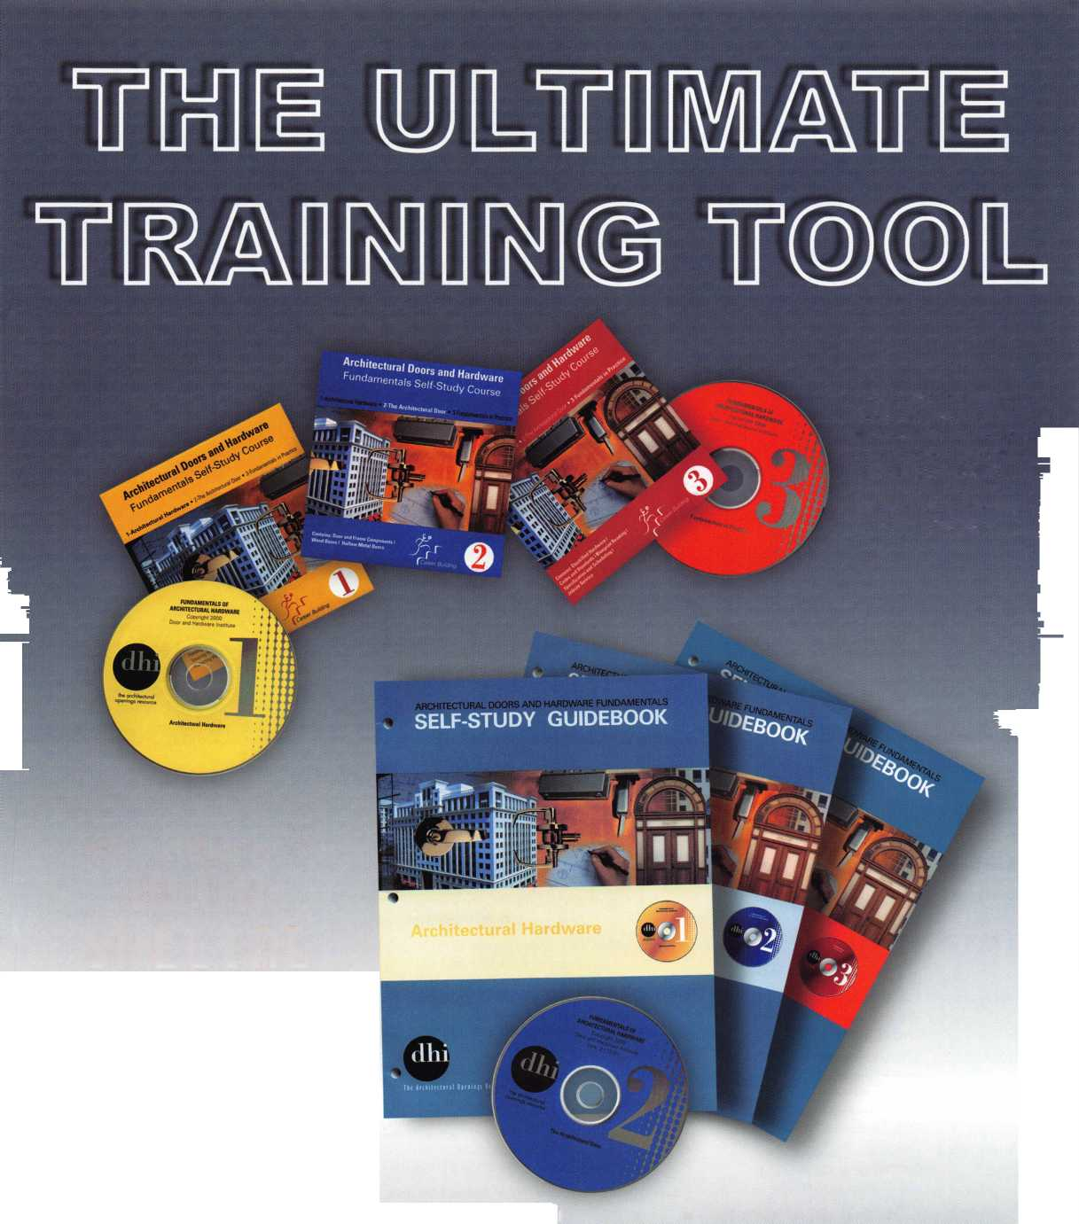

**NOV I OCT SEPT**

|  |  |  |  |  |
| --- | --- | --- | --- | --- |
| u | P c | O | m i | " 9 |
| 3 Ohio Valley Chapter of ALOA  Membership Meeting 7pm Ryan's Steakhouse  Middletown, OH (off exit 32) Mehdi Zahedi (937) 294-4241 | 6-7 Ozark Prof. Locksmith Assoc. Assual Distr. Show and Clinic Eureka Springs, AR  Betty Gray 479-524-3660 | 18-20 Lou-Miss Locksmith Assn.  Fall Convention Biloxi, MS  James Portie, CRL [lockjock@bellsouth.net](mailto:lockjock@bellsouth.net) | | 19-21 Assoc, of Ontario Locksmiths  30th Anniversary Convention  Sheraton Parkway Toronto  888-272-8265 |
|  |  | | | |
|  |  | | | |
| 1 Ohio Valley Chapter of ALOA  Membership Meeting 7pm Ryan's Steak House  Middletown, OH (off exit 32) Mehdi Zahedi (937) 294-4241 | 14-18 Pacific Locksmith Conference Holiday Inn - Airport  Portland, OR  Stan Hauer 503-325-7334 [www.pla-pro.org](http://www.pla-pro.org) | i 14 | Fox Valley Chapter  Membership Meeting 6:00pm Appleton, Wl  David Clark  [daveslocknkey@greenbaynet.com](mailto:daveslocknkey@greenbaynet.com) |  |



UPCOMING PRP SITTINGS

|  |  |
| --- | --- |
| 9/11/2003 | 8:00AM • Dallas, TX • ALOA  Janelle Ramirez 800/532-2562 X30 |
| 9/21/2003 | 8:00AM • Anaheim, CA  Clark Security Products  Joan Emrick 619/718-7308 |
| 9/28/2003 | 8AM • Kansas City, MO Missouri-Kansas Locksmith Assn.  Greg N. Brandt, CML816/444-3233 |
| 10/9/2003 | 8:00AM • Dallas, TX • ALOA  Janelle Ramirez 800/532-2562 X30 |
| 10/17/2003 | Friday PM • Portland, OR  Pacific Locksmith Association  Dan Cunningham F-360-835-1191 |
| 10/18/2003 | 10:00AM • Chamblee, GA  GA Chapter of ALOA  John C. Elliott,Jr.,CML,CPS 770/314-7859 |
| 10/25/2003 | 9:00 AM • Sturbridge, MA  Yankee Security Convention  Jack Hobin 800/209-8266 |
| 10/19/2003 | 9:00 AM • Syracuse. NY  Central NY Locksmith Assoc.  Ron Smith 315/658-2368 |

10/26/2003 10AM • Mt. Laurel, NJ • G.P.L.A.

Martin Arnold, CML 856/665-0464

11/13/2003 8:00AM • Dallas, TX • ALOA

Janelle Ramirez 800/532-2562 X30

11/16/2003 TBD Montgomery, AL

Alabama Locksmiths Assn.

Amanda Boyd 334/793-5060 11/16/2003 8:00 AM • Ellicott City, MD

Clark Security Products Joan Emrick 619/718-7308 12/11/2003 8:00AM • Dallas, TX • ALOA

Janelle Ramirez 800/532-2562 X30

UPCOMING ACE CLASSES

Sept. 13-14 Gulf Shores, AL • AL Locksmiths Assn. Amanda Floyd 334-793-5060 Comprehensive 1C I & II (2 days)

Sept. 20-21 Syracuse, NY • Central New York Locksmith Association Ron Smith 315-782-0912 Life Safety Codes & ADA Your Bottom Line

Sept. 20-21 Yalesville, CT • Nutmeg Chapter

William Brooks, CRL 203-269-7643 Professional Impressioning Techniques

Sept. 26-27

Oct. 6-1 1

Oct. 14-17

Oct. 22-24

Casper, Wyoming  
Wyoming Locksmiths Assn  
Gene Ficek, CPL 605-6424542  
Safe Lock Manipulation (2 Days)

Appleton, Wl

Fox Valley Technical College  
http: //www. fvtc. ed u/

Jerry Antoon, RL

P-920/735-2406 F-920/735-2414  
Six-Day Basic Locksmithing Course

Portland, OR • Pacific Locksmiths Assoc.  
Dan Cunningham, CRL  
F-3 60-835-1191  
[danslocksafe@juno.com](mailto:danslocksafe@juno.com)  
(various classes)

Sturbridge, MA • Yankee Security  
Convention • CPS Prep Class (2days)

November 15 Montgomery, AL • AL Locksmiths Assn. Amanda Floyd 334-793-5060 Closed Circuit TV for Locksmiths

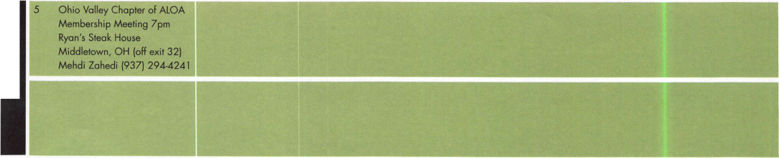

even

t s

21 Fla. West Coast Locksmiths Assn. Lite Seminar with Safe Lock Troubleshooting James Barnhardt [ernie28@ix.netcom.com](mailto:ernie28@ix.netcom.com)



**TURPI ID**

WHOLESALE SERVICE

In-Stock... SAFES  
FREE Freight Program  
Fax: 800-391-4553

800**-**848-9790

AMSEC FireKing Gatdall  
HAYMAN MEILINK Y/CTOK

Locksmith Training

Sponsored by Fox Valley Technical College • 1825 N. Bluemound Dr. • Appleton, Wl 54912-2277

6-Day Program • Career Change in One Week • October 6-11, 2003

This is a basic locksmithing training course sponsored by FVTC’s Security and Crime Prevention  
Department and conducted by ALOA ACE instructors. Designed for the locksmith shop owner  
who would like to provide entry-level training for new apprentice locksmiths as well as those who

would like to receive professional training that will enable employment with a professional locksmith. The course will allow the student  
to gain enough knowledge to make them a starting apprentice in an existing shop. Job placement locations will be made available at the  
time of the class.

To maintain quality the course enrollment will be capped at 12 students. Enroll early!

Curriculum includes:

Key Blank Identification and Duplication Key Codes and Code Equipment Basic Master Keying

Lockset Servicing, Functions, Finishes

Life Safety Codes

Lock Pick Opening Techniques

Pin and Disc Cylinder Servicing Key Impressioning

Lock By-Pass Techniques Exit Hardware

Door Closers

Lockset Installation

Cabinet, Furniture, Mailbox Locks

All tools and equipment will be made available for use during training. Class Hours: 8:30 am to 5:00 pm every day Class Attire: Shop clothes Course Tuition: $995.00

Course Enrollment: See Susan Egnoski in the Criminal Justice Center

or call 920-831-4393

Note: Enrollment deadline is Friday, September 20, 2002

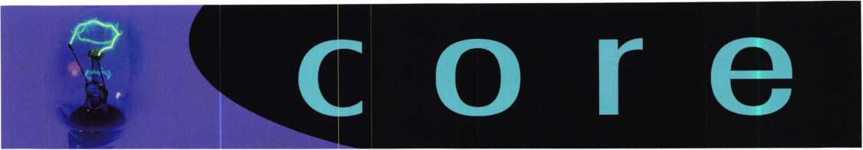

Four Lucky Attendees Win Products at ALOA Show

Kaba recently awarded prizes to four winners of the 2003 ALOA Security Expo give­away in Las Vegas, NV. The prizes included a PowerLever 1550 self-powered elec­tronic lock, a Simplex 5000 heavy duty mechanical push-button lock, a 009 key machine and llco Advantage Software, and an Auditcon 500V with software.

Show attendees entered the contest by completing the entry ballot in the Kaba ALOA 2003 flyer, and dropping the ballot at the Kaba booth during the show. The winners were drawn on the last day of the show, at 2 p.m., July 20, 2003.

The list of winners is as follows:

PowerLever 1550 - Lynda Huisman of Huisman Lock and Key - Sheldon, IA.

Simplex 5000 - Robin Clarke of Master Locksmith - Trowbridge, England

009 key machine and software - Gary Offstein - Glendora, CA

Auditcon 500V - Sam Cramer of Crescenta Valley Lock and Security - Las Crescenta, CA

ALOA Code of Ethics

All members of the ALOA by acceptance and continuance therein, shall be deemed to have subscribed to the following Code of Ethics:

That the dignity of our chosen profession may be perpetuated, it is the duty of all members of the ALOA.

* To practice their profession in the spirit of fairness to their clients, with fidelity to security in conformance with appropriateness, and with high ideals of personal honor;
* To properly and impartially analyze security problems, and to advance the best possible solution for the protection of their clients;
* To conduct themselves in a dignified manner;
* To abide by applicable licensing and business regulations;
* To abstain from using improper or questionable methods of soliciting patronage, and to decline to accept such incompatible patronage;
* To refrain from associating themselves with or allowing the use of their names by any enterprise of questionable character, or in any manner countenancing misrep­resentation;
* To cooperate in advancing the best interest of the locksmithing industry by inter­change of general information and experience with fellow locksmiths;
* To encourage and promote loyalty to the profession, always ready to apply their special knowledge, skill and training for the use and betterment of our industry.

Let Us Know!

If you have an opinion to offer on ALOA, the state of the industry, or life in general, we want to know about it! Submissions to the "Mailbox" section of Keynotes are printed on a space-available basis. Write to: "Letters to the Editor"; ALOA; 3003 Live Oak Street; Dallas, TX, 75240; FAX 214/827-1810; e-mail: [editor@aloa.org](mailto:editor@aloa.org).

|  |  |  |
| --- | --- | --- |
| New | CPSs: |  |
| 09359 | CAMPBELL, WILLIAM R | PHOENIX, AZ |
| 01515 | WARE, THOMAS E. | WAYNE, NJ |
| New | CMLs: |  |
| 43054 | GRAVER, BRANDON T | NEW PROVIDENCE, PA |
| 13387 | HAMBLIN, DELOY J. | OGDEN, UT |
| New | CPLs: |  |
| 20496 | BRICKLER, JAMES T. | CINCINNATI, OH |
| 16347 | HARDING, CLINTON T. | NASSAU BAHAMAS |
| 05795 | HENLEY, PAUL W. | COLORADO SPRINGS, CO |
| 24697 | KUPFERMAN, KEN | TAMPA , FL |
| 11030 | GROESCHLER, BARRY H. | ABERDEEN, NJ |
| 16347 | HARDING, CLINTON T. | NASSAU BAHAMAS |
| 05795 | HENLEY, PAUL W. | COLORADO SPRINGS, CO |
| 40630 | PICERNO, CHRISTOPHER | CHARLOTTE, NC |
| New | CRLs: |  |
| 47325 | AVILA, MATTHEW J | MCLEAN, VA |
| 45374 | BEELER, AARON | LAFAYETTE, IN |
| 42450 | BLOOMER, GEORGE | VERO BEACH, FL |
| 43603 | BROWN, III STEWART K | CHARLOTTESVILLE, VA |
| 23700 | BUSSE,JEANETTE S. | RALEIGH, NC |
| 47211 | CAMP, ROLLAND L | AURORA, CO |
| 4851 | COTE, MICHAEL A. | HENDERSON,NV |
| 41288 | COX, OLISHA S. | RALEIGH, NC |
| 42132 | CYREE, CHRIS W | TALLAHOMA, TN |
| 45694 | GELMAN, MITCHELL H | ARLINGTON, VA |
| 46086 | LARGE, ANTHONY D | PLATTE CITY, MO |
| 25548 | LEISHAAAN, CURTIS M. | LOGAN, UT |
| 29148 | LIA, VINCENT G | PARMA, OH |
| 40621 | SWANSON, DAVID | SPRINGVILLE, NY |
| 47285 | VISSER, CHRISTOPHER J | STAFFORD, VA |
| 28349 | WIEDMAN, JAMES W. | NASHVILLE, TN |
| 43060 | ZIPP, SUSAN | LAKEWOOD, OH |
| 47325 | AVILA, MATTHEW J | MCLEAN, VA |
| 43603 | BROWN, III STEWART K | CHARLOTTESVILLE, VA |
| 47211 | CAMP, ROLLAND L | AURORA, CO |
| 26257 | CHAFFEE, JEAN A. | COLORADO SPRINGS, CO |
| 41589 | DAVENPORT, GLEN J | PERRIS, CA |
| 24567 | DAVID, ROBERT J. | HIGHLAND LAKES, NJ |
| 44510 | DYER, JOSH L | COLORADO SPRINGS, CO |
| 38307 | HAGAN, HARRY E | SMYRNA, GA |
| 25548 | LEISHMAN, CURTIS M. | LOGAN, UT |
| 29046 | LENTS, TIMOTHY J | WASHINGTON, IN |
| 44649 | PARKER, KEVIN D | LAKE WORTH, FL |
| 15285 | REICHERT, RICHARD | LONG ISLAND CITY, NY |
| 45331 | RIDDLE, ROBERT | EDWARDS, CO |
| 47041 | SMITH, NATHAN R | LAYTON, UT |
| 40621 | SWANSON, DAVID | SPRINGVILLE, NY |
| 47285 | VISSER, CHRISTOPHER J | STAFFORD, VA |
| 28349 | WIEDMAN, JAMES W. | NASHVILLE, TN |
| 19602 | HAYNES, ROY L | ARTESIA, NM |
| 14627 | SANDOVAL, KENNETH F. | TEMPE, AZ |
| 29122 | MCCAN, BRICE A. | ALBEQUERQUE, NM |

Keynotes • September 2003



*those who passed over it on their way to Virginia City and the gold recently discovered there. Fuller also provided gold-seekers with a place to rest, purchase a meal, and exchange information with other*

*prospectors.*

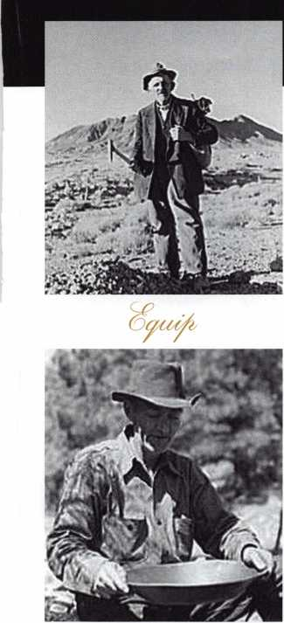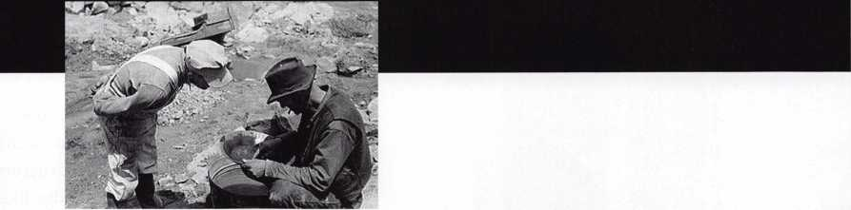

Keeping up with the latest the industry has to offer has never been more impor­tant for safe technicians. Time is of the essence when it comes to education. New developments spring up each year, making top-notch safe classes as good as gold in our ever-changing environment. The only chance to get world-class education and meet with the industry's top safe technicians and suppliers is the SAFETECH Convention and Trade Show. SAFETECH 2004 offers you a chance to explore your profession in ways you never thought possible. Register now to benefit from the future of this exciting industry.

• cj/? diwy/e mcdJ

ewm/ cy/ rfAo da^ a^ic/ voa/t wic/udtiy.

/

**SAFETECH 2004**

MARCH 20-28  
JOHN ASCUAGAS  
NUGGET RESORT  
RENO, NEVADA

VEGAS, BABY.

VEGAS.

By Jim DeSimone, Editor

In the midst of the glitz and glam of sunny Las Vegas, ALOA  
staged its 2003 show and got an overwhelming response from the  
industry Attendance at this show was higher than it has been in  
years, and manufacturers were out in full force at the Security  
Expo to show off what turned out to be a veritable marching  
army of new products. It was a blistering week for ALOA, and  
one that will not soon be forgotten. From Elvis (impersonators)  
to Mr. T (the Real McCoy), the ALOA show kept turning up  
surprise after surprise.

It started strong on Monday, July 14, 2003, with a swarm of knowl-  
edge-hungry class participants waiting for the industry’s finest

instructors (ALOA ACE instructors, of  
course) to drop lock knowledge like there  
was no tomorrow - but there was.

Actually, there were five more days of  
classes to come, and every security topic

under the sun was thoroughly covered. We  
went from cars to safes to detention locks

to electric locks to history to busi-

ness to investigative and institu-

tional locksmithing. We cov-

ered master keying,  
transponders, combination  
locks, financial manage-  
ment, life safety codes,  
project management,  
motorcycles, high security  
cylinders, mechanical push-

button locks and virtually every

manufacturer certification  
available today.

And those were just the classes. The Security Expo featured the most and the best that the industry has to offer, with gaggles of products at every end of the spectrum. Attendees

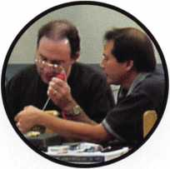

Keynotes • September 2002

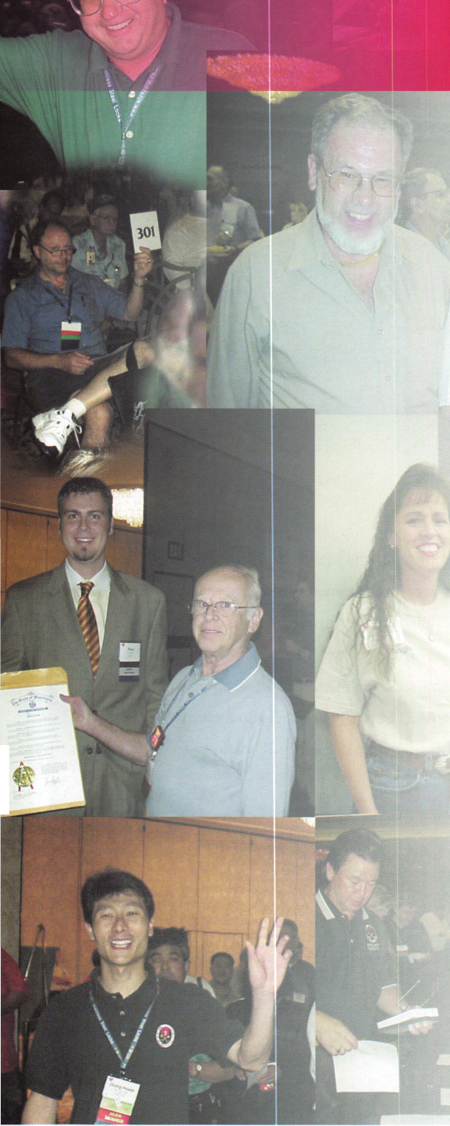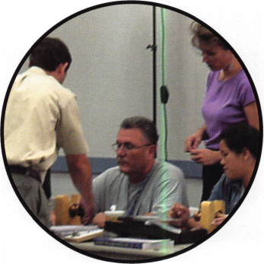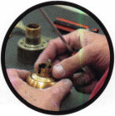

2003 ALOA Convention

and Security Expo

responded by taking to the floor to check out the latest products, and to enjoy all the entertain­ment and freebies available, which consist­ed mostly of food, handouts and Mr. T himself! The former star of such hits as Rocky III and the The A Team, the one-of-a-kind personality delighted fans for hours with his antics at the Medeco booth, where he was signing autographs.

Aside from the classes and the show, there was the ALOA Scholarship Foundation’s Kickoff Party and Live Auction, featuring a spot-on Elvis impersonator who wowed participants with his singing and danc­ing. Hundreds of products were auctioned off at bargain basement prices (and as tax deductions) for the ASF’s benefit.

All told, nearly $40,000 was collected for the cause. Thanks to all who helped out.

The ALOA Open Golf Classic was very well-attended this year was well, and by the end of the day, thousands in golf equipment was given away as prizes to participants. All told, this year’s golf tournament chipped in an additional $13,000 to the ASF’s worthy cause.

There was also the tour of Hoover Dam and Lake Mead, in which an enormous tour bus was packed with visitors wanting to take in the scenic views.

The icing on the cake came Saturday, though, as the Annual Banquet hosted Martin and Romano, “The Ultimate Blues Brothers Tribute Band.” Everyone was up on their feet dancing, and it was such a fitting way to end the show, Vegas style.

To all those who attended, congratulations on being a part of a fantastic and memorable show. Everyone at ALOA is anxious about next year’s show in Baltimore, where we have even more surprises up our sleeves. See you there!!



Keynotes • September 2002

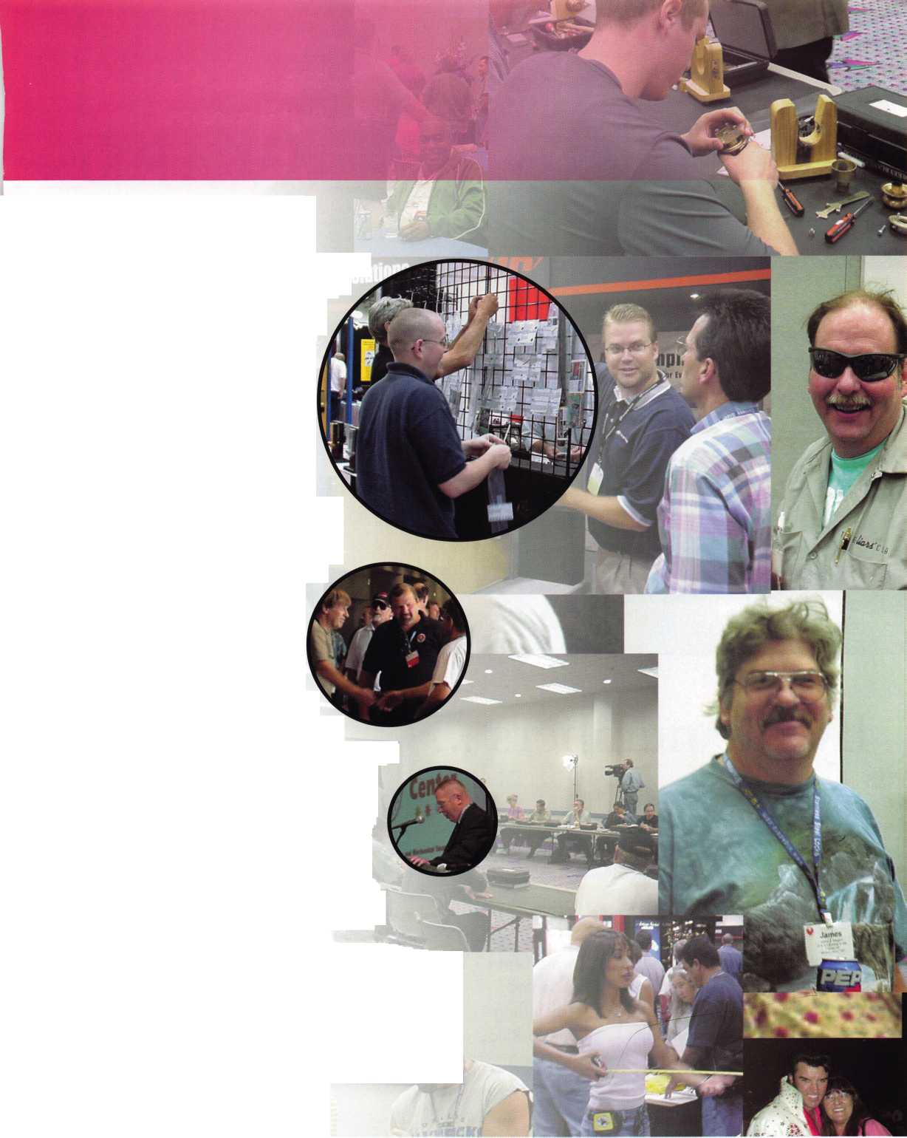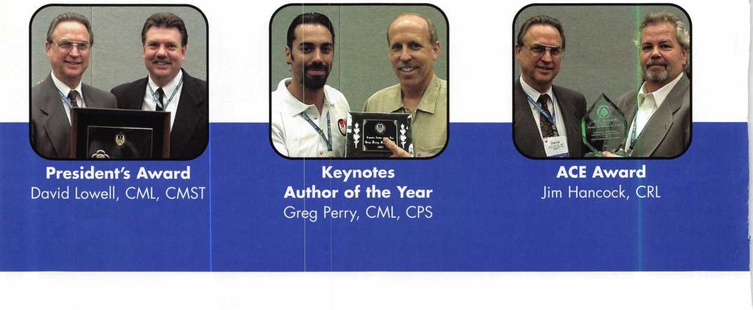

By the numbers ...



Over 3,300 participants



1 1 1

international  
attendees from  
29 different  
countries all  
around the  
world.



All 50 of the  
U.S. states  
were repre-  
sented,  
including  
Puerto Rico.



An averaqe of  
330  
students  
attending  
ACE classes  
each day.



Over 10,000  
student hours  
of professional  
instruction.



Over $40,000 raised by auction for the ALOA Scholarship Foundation.

Keynotes • September 2002

**You're Safe with SNA**

Get Whats  
Coming To You

AIOA continues to provide vou with this and other great benefits and services!

*VmKm*

■

mm

LDUD UL> UL)dDUL)

dbcipCD

lDGDGD

< >

Need information in a hurry?

Use ALOA’s Fax On Demand service.

Just call 310-575-5074 and receive:

1. ALOA Index of Documents
2. Becoming a Locksmith (Ipg)
3. Locksmith Career Summary (3pg)
4. Locksmith School List (2pg)
5. ACE Class Schedule (8pg)
6. Certification lnformation(3pg)
7. PRP Category List (Ipg)
8. ALOA Membership Application(2pg)
9. ALOA List of Benefits (Ipg)
10. Scholarship Application Form (Ipg)
11. ALOA Video Library Order Form (1 pg)
12. ALOA Membership Items Order Form (Ipg)
13. Safe & Vault Technicians Association Member Application/Subscription Form (2pg)
14. ALOA Chapter Roster (3pg)
15. Legislative Action Network (2pg)
16. Legislative Action Network Newsletters (Ipg)
17. Various State Laws (lOpg)
18. Industry Position Pager (Ipg)
19. Current Legislative Action Network Newsletters (Ipg)
20. Board of Directors Nomination Form (2pg)
21. ALOA Convention Registration
22. ALOA Board Expense Reimbursement & Request Form

310**-**515-5014

**Widest Selection**

**at the Best Prices**

**Meet us at the ALOA Security Expo 2003!**

Modern and tough-built, our safes have superior quality and a better price. Offer your customers more - from under­counter safes to depositories to burglar and fireproof composite safes. We have the widest selection.

For a catalog or to place an order call 1.800.421.0381



**S.N.A, Inc.**

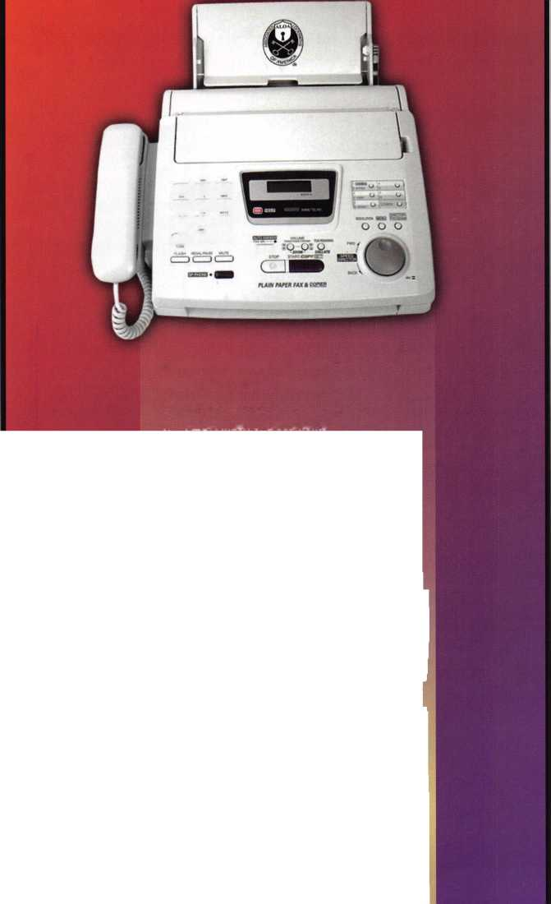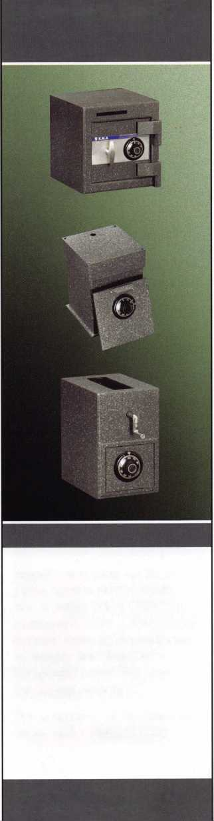

ALOA to Members:

We Will Protect You from New Threats!

ALOA is going to protect you from several mounting industry legislative battles this year. But we can't keep our commitment to protect our members at the old prices. New threats are on the horizon in 2004, and we need your help. We need you to do your part to protect yourself, so that our industry can continue to prosper. Here are some of the things our Legislative team has been working on, so that you can see the kind of efforts we're planning to make on your behalf next year, and beyond.

On your behalf, ALOA's Public Policy department has maintained a positive legislative environ­ment for ALOA members. The department has accomplished the following end results for the year:

DEFENDING MEMBERS UNDER DIRECT LEG­ISLATIVE ATTACKS ALOA gave effective representa­tion of the members to legisla­tors, regulators, and other indus­tries this year.

* ALOA effectively represented members interests opposing bills that would impede lock­smiths to do their work in Connecticut, Maryland, Mississippi, Ohio and Pennsylvania. We were suc­cessful in getting these bills either killed or amended.
* Assisted the Ohio Locksmith Association in acquiring a lob­byist to defeat the alarm bill. Successful in obtaining fund­ing from SHDA for this lobby­ist.
* ALOA chaired the Electronic Systems Alliance meetings. The mission of these 12 asso­ciations in the low-voltage industry is to exchange and discuss information regarding legislation impacting the elec­tronics industry.

"There is no doubt that  
ALOA spent big dollars  
to come to Ohio and  
fight threatening legisla-  
tion from the OBFAA  
backed bill in '02. Had  
that bill passed, there is  
no doubt that the lock-  
smith industry would  
have suffered a serious  
blow. A team effort was  
and still is needed to  
stay ahead of legisla-  
tion!! Legislation has a  
'trickledown and  
around' effect; what is  
in your state today is  
coming to my state in  
the near future. ALOA,  
thanks for your help!!"  
*Ron Betschman CML.*

Monroeville, OH,  
Member #9477

Passed the International

Association of Security and Investigative Regulators (IASIR) model law on licensing electronic security systems to make it more favor­able to locksmiths.

Visited key Congressional legislators and lobbied for the locksmiths' interests in the Motor Vehicle Owners' Right to Repair Act.

MONITORING BILLS THAT MAY HARM MEMBERS

ALOA's membership is informed by monthly coverage in Keynotes and periodic updates through direct mail and e-mail. The ALAO membership is consulted about any and all legislative activity that may affect it.

* Monitored over 500 bills related to the security industry, focusing on 16 of them in 14 states that directly affected locksmithing.
* The Legislative Report page on the ALOA website was updated constantly on these 16 bills to give members up-to-the-minute information on legislative activi­ties in their state.
* Developed an "Action Alert" page where members may look at specific bills, their status, and write a letter to the appropriate legislator. Used it extensively for Ohio.
* For all bills, notified the Chapter Chairman, or Association President of pending legislation. Sent letters, faxes and emails to all applicable LAN and ALOA members notifying them of these bills and asked them to take action.
* Produced a Legislative Report in all issues of

"The ALOA Board deals with legislation on a weekly basis, and takes locksmithing legislative concerns very, very seriously. Any member who thinks that all you get from ALOA mem­bership is a magazine and convention should check out what goes on behind the scenes. Because without our legislative team working to kill bad bills - a good example close to me is the recent "Do Not Duplicate" legislation ALOA helped to stop in my home state of Tennessee - who knows where we would be today?"

Vince Formon, CML,  
CPS, Memphis, TN,  
Member #15905

Keynotes magazine.

Conducted a State-of-the-States roundtable at Convention with over 21 Chapters, Affiliates and Locksmith Associations in attendance.



Keynotes • September 2002

PROACTIVE LICENSING LEGISLATION TO HELP  
BOLSTER THE POSITION OF LOCKSMITHS

Accessible and effective guidance and programs to achieve

desired results.

* The Association Affiliate program is designed to promote

the profession of locksmithing by strength through num-  
bers. For the Government Affairs Department, it is an  
accessible and effective program to be heard by gov-

ernment. In 2002 we had 21 Affiliates signed up.

One of the Affiliates (Gateway Locksmith  
Association) became the new Bi-State Chapter  
of ALOA.

* The Legislative Action  
  Network continued to  
  inform and energize  
  members about legislative

matters. 2002 saw the total

number of LAN members rise to  
over 500 in 44 states. 257 of them  
donated over $14,000 to the  
Legislative Fund.

* An extensive legislative "How To" guide  
  premiered at the Convention. It has vari-  
  ous strategies used in getting a locksmith  
  licensing bill passed, how to defeat or  
  amend an alarm licensing bill and an  
  updated model law.
* Worked to turn around the situation in  
  Maryland to include locksmiths under  
  the Security Systems Technician Act  
  with our own acceptable language.
* Worked extensively with the Coalition  
  for Auto Repair Equality (CARE) on the  
  passage of the Motor Vehicle Owners'

Right to Repair Act.

* Began the process of introducing  
  federal locksmith legislation by securing  
  a Washington D.C.-based lobbying firm.

Another function of the Public Policy Department is to make sure the  
membership is recognized by various entities. The department has  
accomplished the following end results this year for recognition by:

SECURITY PRODUCT MANUFACTURERS  
• Attended the Security Hardware Distributors Assn. Spring and Fall

meetings. Secured funding for a lobbyist in Ohio. Pushed for finan-  
cial support of federal locksmith legislation.

RELATED INDUSTRY GROUPS

• ALOA continues to be represented at ISC West, ISC East

and NBFAA Board meetings with staff or Board mem-

bers in attendance at their industry  
meetings. ALOA chairs the  
Electronic Systems Alliance (see  
above).

Chair of the North  
Carolina Licensing Board,

Raleigh, NC, Member #26808

INSURANCE UNDERWRITES

• ALOA continues to work with the  
Insurance Association of Connecticut to pass

the locksmith licensing bill in Connecticut.

GOVERNMENT

• ALOA worked with various locksmith associations  
for "Locksmith Day" proclamations including  
Wisconsin, South Carolina and Oregon.

The ALOA Board of Directors has enacted a $25

Legislative surcharge to the regular ALOA dues  
for all active members in the USA (and territories)  
in 2004. No foreign, retired or apprentices will be  
asked to pay the surcharge, as ALOA does not  
fight foreign legislative battles. If you live in the  
United States or its territories, you must pay the  
surcharge to maintain your membership. The sur-  
charge will be payable during this year's dues  
billing, which goes out Oct. 1,2003. As directed  
specifically in writing by the ALOA Board, the pro-  
ceeds from this surcharge will be available for use  
ONLY in ALOA's legislative efforts.

ALOA is excited about the challenges that lie ahead, and we're waiting for our members to let us after those groups that are aiming to legislate locksmiths out of business, one bad bill at a time. We're ready to do our part for the prosperity of this industry. Please help yourselves by doing your part this year. Prove that you are a serious professional locksmith by sticking with ALOA during these new challenges.

Keynotes • September 2002

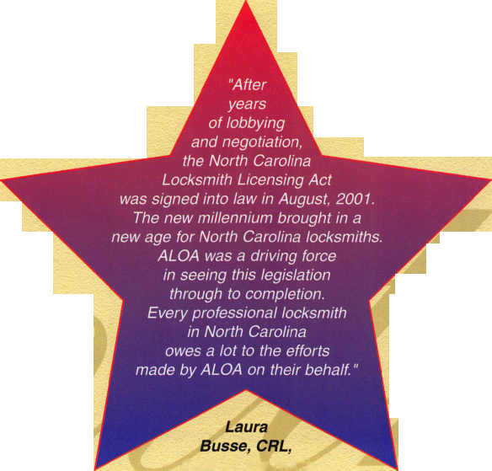

Tool Parade!

ALOA Show Standouts that Save Time and Money

By Greg Perry CML, CPS



This year’s ALOA show in Las Vegas was outstanding. The venders did an excellent job of showing off both their new products as well as their existing product lines. I wanted to highlight some of the new products available that are new and/or improved. Next month, we’ll look at some of the electronic test equipment exhibited by Triplett. This was their first time at an ALOA show (they said they’d be back next year in Baltimore), and I'll cover some of the other tools available to the electronic access control technician.

Peterson International caught my attention with their large display of lock picks, bypass tools and extractors. I liked their set of extraction pliers so much, I purchased a set. Three different configurations of pliers can be seen in photo i. The first is an ice tong extractor plier; it grips similar to two hook extractors. I’ve used two hooks in the past with some success, but found it difficult to always get the perch, or grab, on some keys. Building them into a pair of pliers should make grabbing broken keys easier. The next two pliers seem even more useful. They have an angled saw blade on their tips. One is a left-over-right layout and the other is a right-over-left layout; these will be a big help with broken Geo and other automotive keys with opposing wafers, which break off deep into the lock. The biggest problem I’ve found is trying to wiggle the broken por­tion past the wafers. It always seems like one wafer just won’t allow it past, and the extractor slips off. Hopefully, these pliers will keep the wafers out of the way and allow a strong pull on the broken key.



Keynotes • September 2003

I

Master Padlock introduced a new cylinder at the show.  
^The plug houses a pair of ball bearings. The keys have

a dimple cut into them to match the location of tjfe  
ball bearings. They are awaiting a patent and will  
offering both an open key section and restricted sec-  
tions by region. Different configurations or locations  
of the ball bearings are how they will achieve the vari-  
ous sections. The cylinder assemblies use the same pins  
as standard cylinders so the only investment will be in  
cylinders. The additional price of the cylinders will be  
minimal so w;$ .jgll be able to provide ^^>erior prod-  
uct for very little cost. ^

Major Manufacturing brought a couple of new prod-  
ucts to the show that caught my eye. First was a door  
lifter on a lazy Susan. (IVe used pry bars and brute  
strength in the past.) This lifter will make taking off  
and installing doors far easier. I'vejped it on a couple  
of doorsJ^The only drawback -- if you can call it that --  
is the height limit. The lifter will only lift a door about  
2 inches, and sometimes the floor slopes away or dips  
down from the threshold. In a case where the lifter will  
not lift the door high enough, a shim of some sort  
should be placed below the lifter. The next tool they  
offered is a cabinet lock installation jig. They only  
brought a prototype to the show, but it incorporates a  
few things I suggested last year, after trying out a com-  
petitor's product. First, it has bushings for all few §^es  
of holes: 3/4, 7/8, 1 1/8, and 1 1/4 inches. Second, it has  
depth stop; this is very handy when installing multiple  
locks on a row of cabinets or drawers. I did not get to  
test or try out this tool, but it looksjhke a worthwhile  
tool. Major also has introduced fifth a double "D" and  
single "D" sheet metal hole punches. Similar punches  
were discontinued several years ago by HPC, and since  
this time, installing cam locks in sheet metal cabinets  
often irwolved an exercise in frustration.

Bob Stabley with LA Safe and Vault always has some-  
thing new and different for the safecracker. This year,  
he brought out a quick coupling adapter for the  
StrongArm Mini-Rig. A very simple tool, but it makes  
^^e3t tool even greater for those of us

who use two different drill motors for diamond core drilling, or who like to check the progress while drilling hardplate. It chucks up in the drill and has a female

Major Manufacturing door lifter

Peterson International extraction pliers



Keynotes • September 2003

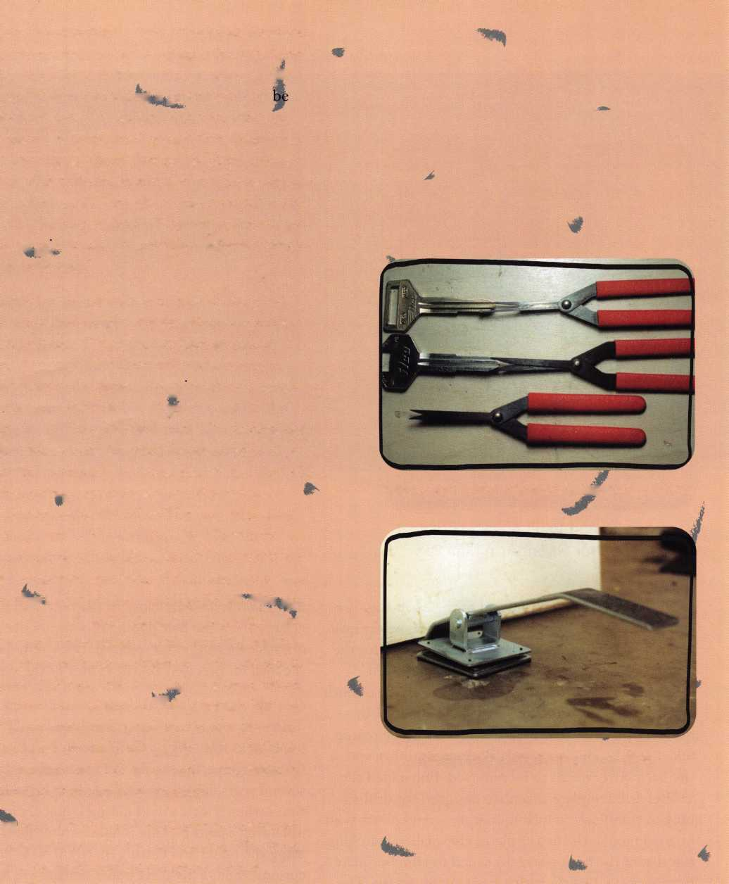

LA Safe and Vault drill

LA Safe and Vault quick coupling adapter for StrongArm Mini Rig

socket the exact size as the end of the Mini-Rig. It is very much like the adapters used with the better qual­ity lock installation jigs. The other tool is just for the GSA safecracker; it is a drill guide for the LOBC (Locked On By Combination) pin on the back of both Kaba-Mas X-08 and X-09 locks. This pin must be drilled off if the bolt will not retract for some reason (like a lost combination or bad stepper motor), and the back cover needs to be removed. Bob added the LOBC drill template to a plate designed for drilling broken combination lock mounting screws. Ours is an original model; the newer plates are smaller, matching the size of the back cover. I needed to trim our plate for use on a CD-X09 with a bad stepper motor. The original design of the plate is for safes with LaGard electronic locks. You can drill a hole on the center bolt and punch (or more often, tap) the hole and use a bolt to press the combination lock over, since the lock uses only three screws to hold the lock to the

door. Two screws are close to the bolt, and the third is away from the bolt. Doing this shears the screws off, necessitating their removal. Bob’s template aligns the drill bit precisely on the center of the screw.

Last up -- since this was done in reverse alphabetical order -- is a new tool for opening Schlage ”F" series knob locks, the QP-i puller from A-i. I've used their QP tool for pulling Kwikset 400 series cylinders for several years. This tool has bailed me out a number of times when a lock would not pick quickly for me. My usual time spent picking is about 10 minutes before using the puller and getting on to the next job. I was curious; the QP Kwikset puller defeats the lock because the cylinder is retained by two spring clips, and it can be pulled out of the face of the knob. This rarely causes any damage and on the occasional time that it might, Kwikset cylinders are inexpensive to replace. Schlage cylinders are contained inside the

Keynotes •September 2003

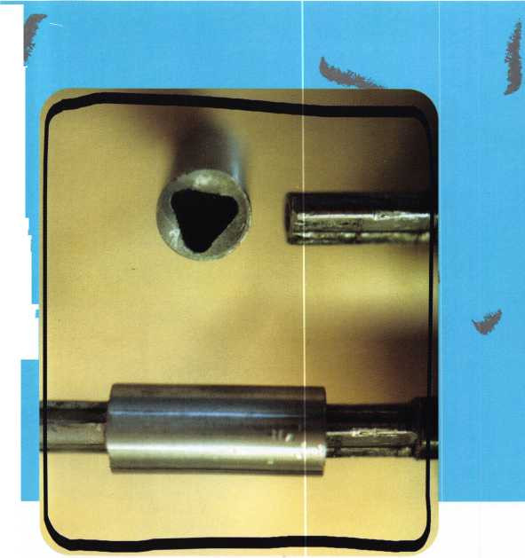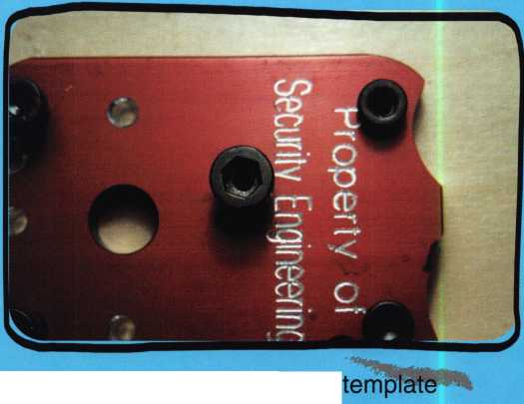

knob. How can a puller not cause major damage? Well it does cause repairable damage, and they include the repair tool. The puller stretches or pulls the cylinder against the face of the knob. This allows you to depress the knob retainer and remove the knob. Once the knob is off the lock, it's simple to reach in and turn the tailpiece of the spindle. Next, the cylinder is removed from the knob and a screw and reforming die or tool is used to reshape the knob. If opening the lock was all A-i had in mind, this is a good tool, but A-i sells it with a different intent. The salesperson suggest­ed using the ease of opening with a force tool as a way to upsell your customer to a better quality lock. I’ve always tried to hide the use of the Kwikset puller in shame at not being able to pick the lock quickly. I would rarely let my customer see how it worked. The salesperson's suggestion makes a lot of sense. Demonstrate to your customer how easy it might be for a thief to use a tool like this to open their lock.

Not every customer will purchase better locks, but the ones that do will add to your bottom line. Most hard­ware stores and home centers don't offer the better locks, so you don't have to compete head to head on a low profit margin lock. Instead, you can up sell to qual­ity lock with a decent margin. Of course you may regret it later when the same customer locks himself out, and your picking skills are not up to par that day.

Next month we'll delve into the tools used by alarm and access control technicians. Once learned, the skills for installing electronic access control command a higher wage and usually a higher overall bottom line on the invoice. Like any industry, there is a learning curve and an investment need in tools. We'll look at both the required tools and "nice to have" tools.

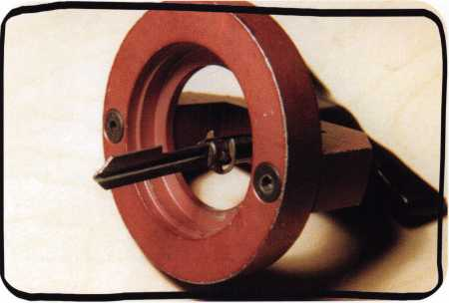

QP-1 puller from A-1

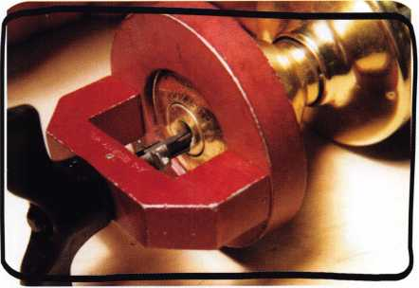

QP-1 puller from A-1

Keynotes • September 2003

Basic Impressioning Part 2: Preparing the Key Blank

By Jim Hancock, CRL

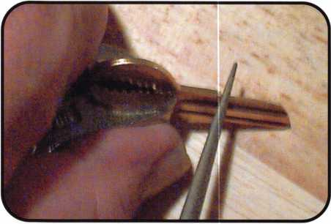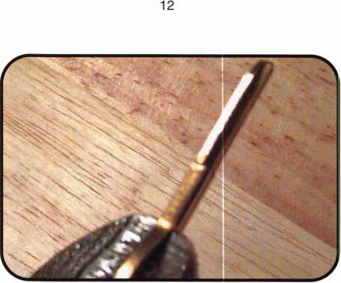

13

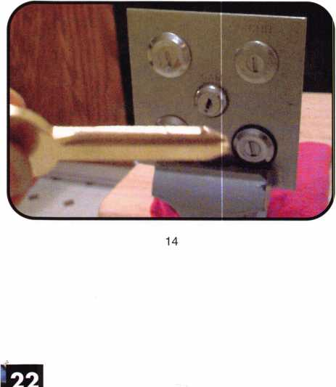

Now with the proper tools in hand, we are almost ready to  
start impressioning. But first, we have to prepare the key  
blank to accept the marks left by the lock. Without proper  
preparation, you very well may not see the marks, and there-  
fore not be able to make the key.

The key blanks we use today are generally going to be made  
of a choice of two materials: either brass or nickel silver. In  
either case, the blank has a plating over the raw base materi-  
al. This plating is what causes you to have to brush a key you  
have just duplicated. If you look closely at a duplicated key,  
you'll see material rolled to the side of the blank. This is  
because the plating doesn't cut through properly and holds  
onto the key. It is this plating we must get rid of before  
impressioning. The plating does not lend itself to marking  
as well as the raw base material will. Also, in regards to the  
materials, it is important to remember that nickel silver is a  
harder base than brass and, therefore, it will be harder to  
achieve and identify marks on a nickel silver blank.

PLATING, CLEANING, SHINING

The first method we will use to prepare the blank is called  
cleaning or shining the key. With this method, you simply  
remove the plating from the top of the key blade without  
removing any of the blank material. In photo 12,  
you will see the beginning of the process used to shine the  
key. The blank is held against a solid surface with one hand.  
With your file in the other hand, you brush across and down  
the key blade from shoulder to tip, called draw filing, until  
the plating material is gone and you are left with a nice  
matte surface (photo 13). It is here that you will need to  
develop good filing skills. You cannot let the file drift and  
leave unwanted markings on the blade. And unless you are  
using a flat file to clean the blade, it is easy to leave a roll on  
the blade from the conical shape of the file. You must learn  
to make the file do what you want it to do.

Keynotes • September 2003

Another method of key preparation you might consider is  
what is called blading. This requires taking the key blank  
and turning it and the file at 45-degree angles from each  
other, bringing the blade to a fine edge, like a knife (photo  
14). In fact, if done correctly, the blade will be sharp enough  
that it will cut you. The bonus to making this preparation is  
that it removes a great deal of the material from the blade,  
which allows the pins or disk tumblers to bite into much less  
material, thereby leaving a more pronounced mark. The  
downside to this preparation is that, if you’re not careful, on  
some locks, the mere act of blading will remove enough  
material that you possibly will start with a key blank that is  
already too deep.

Other prep methods I have seen or heard about have their  
own pluses or minus:

* Using emery cloth to shine a key blank. As an initial  
  process to clean the plating off the blade, this actually  
  works pretty well. Leaves a great matte surface.

However, much more difficult to use once you begin to  
actually make cuts in the key.

* Smoking the key Holding the blade of a key over an  
  open flame such as a lighter does this. This leaves a  
  heavy soot finish on the key. This method is not recom-  
  mended for any other reason than the lock properties.  
  When you slide the soot-stained key into the lock, the  
  pins or wdisk tumblers will drag along the length of the  
  blade and generally wipe off most of the soot. This also  
  doesn't work after the initial spacings are cut because  
  the pins or disk tumblers will consistently leave indica-  
  tions on the key. Smoking the key is a useful method of  
  obtaining spacing marks on a lever-type lock because  
  the levers do not touch the key until you actually turn  
  the key.
* Lipstick, Magic Marker, White Out etc,.

See above.

You can certainly experiment with many different things to enhance your ability to see the marks. Let's face it: Most of our business and procedures are derived from someone say­ing " What if I try this?" But blading and shining are the two preferred methods, and are both proven. It will all come down to three words: PRACTICE, PRACTICE, PRACTICE.

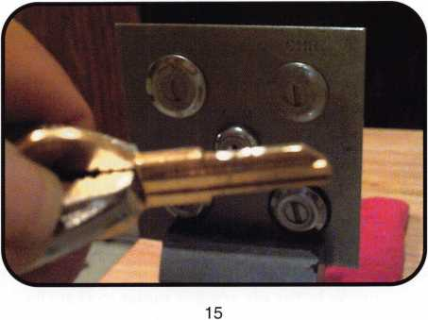

Keynotes • September 2003

HOW AND WHY IMPRESSIONING WORKS

I will assume that if you are reading this, you already know the basic operations of a lock mechanism. So we won't dis­cuss that; however, we will go through the principles that make impressioning possible. You already know that with no key in a disc tumbler lock, the tumblers protrude out of the plug into the disc tumbler track in the housing, thus creating a blockage at the shear line, which is why the lock won't turn. With a blank key inserted into the same lock, the tumblers are pushed up to their highest point, protrud­ing out of the opposite side of the plug, blocking the oppo­site shear line. In a pin tumbler lock, with no key in the lock, the bottom pins rest against the register in the plug, and the drivers are pushed downward by the springs and create the shear line blockage. When a blank key is insert­ed in the lock, the pin stack is raised so that the drivers are now in the bible of the lock, and the bottom pins create the blockage.

In either case, when a blank key is inserted, if we put turn­ing pressure on the blank key, the pins or discs are now being bound by the pressure, between the plug and hous­ing. With the proper preparation of the blank and the proper movement of the blank, the tumblers, with their restrictive movement, will be forced into the key blank and leave a mark. What we will now start learning is the proper methods to achieve these marks, as well as what the marks will tell you beyond location.

IMPRESSIONING A DISC TUMBLER LOCK

We will begin our practice of impressioning on a disc tum­bler lock. We start here because fully 80 percent of the impressioning you do will be on disc tumbler locks. The property of the disc tumbler itself, key going through the center, pronounced edges on the bearing surface, generally leads to better marks than a pin tumbler.

In photo 15, you'll see a prepared blank already inserted into the vise grips and ready to go into the lock. Make cer­tain whether it's a disc or pin tumbler that you always insert the key and remove the key from the lock in what we call the neutral position, meaning no pressure on the discs or pins. Otherwise, you could have secondary scarring of the blank and wipe out whatever marks were there, or worse, making marks that really don't exist. Once you put the key into the lock, you want to turn the key with good pressure and exert the bind on the discs or pins needed to achieve a good bind (photo 16). With the discs or pins bound, you will now need to bump the key. Bumping means moving the key in a motion that basically drives it into the pins or discs. In other words, moving it up and down toward the pins or discs. Not a side to side motion (photo 17). How many times do you bump the key? Well technical­ly, once you bump it, the bind on the discs and pins change, so you won't achieve any greater marking by bumping more; however, it won't hurt anything to bump several times. Also, make sure you turn the plug in both directions to allow yourself a greater chance to pick up marks.

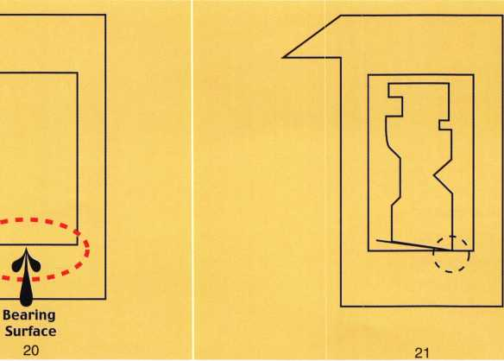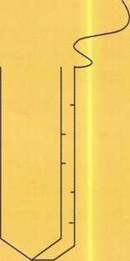

22

Keynotes • September 2003

Once we have performed our turn and bump, remove the key and let's check the blade. What you should see is a pret­ty typical disc-type mark on the blade in positions 2 and 3 (photo 18). I know that there are tumblers in 1, 4 and 5, but they may not show up just yet for a couple of reasons. One would be that they are possibly "o" cuts, meaning they are already at the shear line. If this is the case, then they won't bind and mark. The other case would be the manufacturing of the locks themselves. As you know, on both disc and pin tumbler locks, the chambers are not all in perfect alignment with each other. This is why picking is possible and explains why not all pins or discs will show up when you attempt to impression. Be patient; they will appear if they bind. It is now at this point I need to engrain upon you the NUMBER ONE rule of impressioning: NEVER CUT WHAT YOU DO NOT SEE. It is always possible to cut more, but you cannot put the metal back.

In the next photo (19), you will see the same key after the initial cuts have been made at the marks we saw. Notice that the cuts are very clean; no marks in the bottom, that same pristine finish that started our blank. This is very important to you. You must always get this shiny surface when you have made your cuts. This is the only way you will ever con­sistently see the marks. After cutting your marks and then cleaning up your cuts, you will again insert the key, bind it and bump it. This should again yield marks, possibly new ones, possibly in the cuts already created. If you see it, cut it. If this process is followed, at some point, the key will turn.

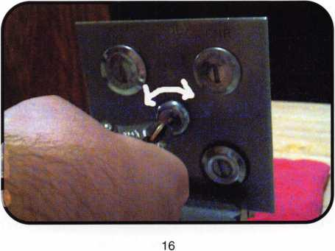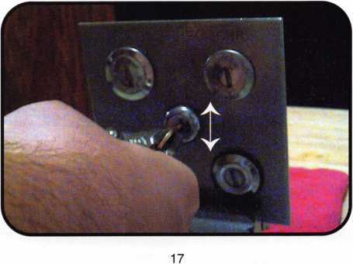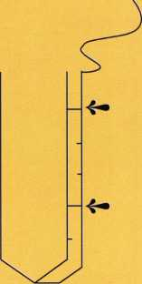

23

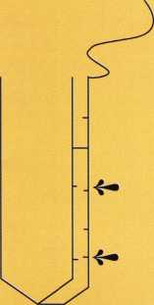

24

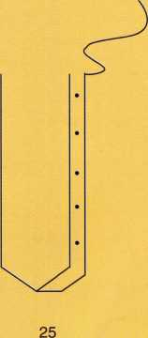

Keynotes • September 2003

WAFER MARKS

Let's take a moment to discuss the possible types of marks you may see when impressioning a disc tumbler lock. Because most of the discs you will work with carry the same shape, the marks you will see should look relatively the same as well. The only real exceptions will be specialty discs such as GM, Toyota Split Wafers and 2 or 4 Track High Security types. And yes, these will mark and can be impressioned with a little more knowledge and practice.

Figure 21 shows a typical disc tumbler design. The circle shows the bearing surface of the disc. This is the point of the disc that actually contacts the key, and it is from here that the marks will originate. Figure 22 shows a cutaway of a disc with a key inserted and turned to bind. Notice where the bearing surface contacts the key. The marks you will see from this contact will look much like those in Figure 23. If the chamber that the wafer sits in is fairly snug to the wafer, the wafer will have less side to side movement or kil­ter, and may produce a mark like the one in Figure 24. This is also the same type of mark you might see as the tumbler approaches the shear line. Because the tumbler is close enough to the shear line to get trapped between the plug and housing instead of binding at the side, it will push downward, trying to shear. That downward push will cause the entire surface of the bearing surface of the tumbler to touch the key blade, creating this line.

Occasionally, you will get marks like those in figure 25. You noticed when you turned the key in one direction the mark made was closer to the shoulder of the key. When you turned it the opposite direction, the mark appeared closer to the tip. This is also common and is not an indication that your spacing is off or that there is a wayward tumbler floating around inside that is off-spaced. Again, consider

the disc tumbler properties. Although the tumbler is flat, it does have dimension. And because it is not a perfect item, it is very common that the bearing surface edge is not con­sistent. Because of this, the bind one way creates a mark on one side in the aft position while the tumbler will create a mark in the forward position on the opposite side. When this happens, just split the two marks and cut in the center. Your spacing should be dead on. But ...be careful. The other reason you could be getting these opposing marks in two locations could be your bind and bump. You could be inadvertently allowing your key to back out of the lock slightly, creating these marks. BE CAREFUL.

IMPRESSIONING A PIN TUMBLER

The steps required to impression a pin tumbler lock will be virtually the same used to impression a disc tumbler. From key blank preparation to bind and bump, it will work the same way. The difference will be the marks you will see, and this is based on the properties of the pin tumblers themselves. On the disc tumbler lock, we have the hard edges of the bearing surface that will "bite" into the key blank. On a pin tumbler, we are dealing with a rounded sur­face. This is known as the chamfer of the pin. In a perfect world (we all live there, right?), the chamfer of the pin tum­bler in the locks we impression would be pristine. This pristine chamfer would act somewhat the same way an awl or center punch would against any surface. Because the point on the pin is still "sharp," it would leave a nice little pothole (if you will) on the surface of the key. Easy to see, easy to cut. Now let's come back to the real world. These chamfers wear down with use, and no longer do you have that nice pointed end. Now what you have is akin to taking your awl or center punch and hitting the end with a ham­mer. The point is now flattened or mushroomed, and no

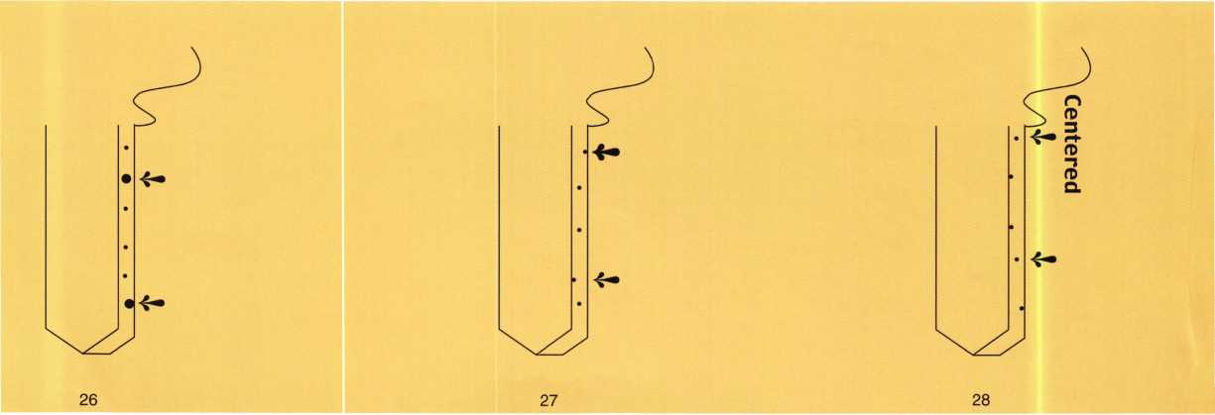

Keynotes • September 2003

longer leaves that nice little dimple, but now will look more like a smudge or rub on the blade surface (figures 26 and 27).

One other note about the marks on a pin tumbler before we look at some more pictures. The initial marks left on the blade when impressioning a pin tumbler will not only tell you pin location, but may also indicate the depth of the pin. Certainly it will not tell you if it’s a 1 or 2 or 6, but it will tell you, with practice, that you can start at a depth of 3 or 4 instead of babying the key from blank to finished cut. This is where your speed increases by being able to read the mark. In figure 28, although greatly exaggerated for your understanding, you'll notice that the marks are off- centered from the blade. They are more toward the edge of the blade. This indicates a shallow cut, perhaps a 1 or 2. In figure 29, you will notice the marks are more centered. This is generally indicative of a deeper cut, perhaps a 3-plus. What causes this to happen? Let's examine it.

The pin chambers in any lock, regardless of manufacturer, are not consistent in diameter and are certainly larger than the pins; otherwise, the pins would not move. When we insert the blank into the lock and turn it to create a bind, the bottom pins are above the shear line, creating our blockage. In figure 30, you will see what occurs when the pin is a short one, or shallow cut. Because of the movement of the plug in relation to the housing, and because of the amount of Mplay" in the pin chamber, and finally, because the bearing surface of the pin against the chamber wall is short, the pin kilters or angles to the side slightly, creating a mark that is off-center. The circles denote where the bind­ing pressure makes the pin contact the chamber walls. In figure 31, note the long pin or deep cut represented. The bearing surface is much greater; therefore, the amount of kilter is much less, leaving a mark more centered.

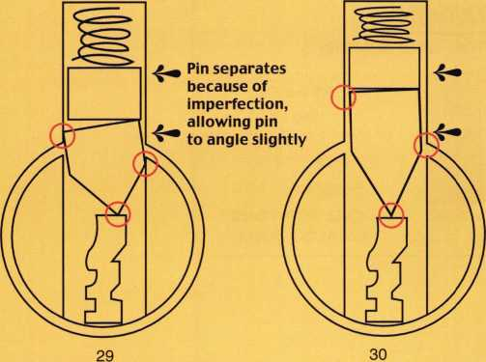

A WORD ABOUT LIGHTING

There will be many things as we try to impression a lock that we will have no control over. A lock under the knee well of a desk, a credenza behind a desk where someone is working and will not take a break to allow you some room, an auto lock that is loose in the door/trunk, and won't hold to allow good pressure. But all of these things can be over­come. The one thing you cannot work around is bad light­ing. Without the proper lighting, your ability to impression drops tremendously. Since a great deal of your time will be spent in an office environment you have to be prepared for a hard fact of impressioning life: Florescent lighting is the worst lighting known to mankind for impressioning. Florescent lighting does not lend itself to reflection, which you will rely on in order to see the marks on occasion.

Many times, you may be forced to walk from the desk you are working on toward a window to use the sunlight. Many times, you will need to have an alternate light source, such as a Black and Decker Snake Light. Also, keep this in mind: Do not fear looking a bit crazy. You almost have to be a contortionist, bending and turning into the light in order to see the marks. And do not forget to turn the key in every conceivable direction to change the shadows on the key blade. More often than not, the mark on a pin tumbler will resemble a smudge, as stated earlier, and the only way you are able to pick up this mark is changing the light.

PENULTIMATE WORDS

As with anything else in our business, impressioning requires multitudes of practice and the patience of Job. It will not come to you overnight, and may not come to you at all. Between eyesight and lighting, key blank material, lock location and customer attitude, sometimes you will want to grab the Dewalt first and use it on the lock (or even the customer). But as I stated at the outset, the ability to impression will serve you well in many instances, and may be quicker and safer than drilling. As you continue to practice, a great deal of what we discussed in this lesson will become second nature. You will see marks when no one else can. You will be able to discern a deep cut from a shallow cut, and begin impressioning much farther into the key than many other people can. You will be able to see a mark's appearance change and realize that the change is because you have already cut too deep. (Yes, locks will mark after you have gone too deep, but the mark changes.) You will know how many strokes of a number 4 cut file it takes to remove .015 inches of a key blade. You will know the depth differential between a number 1 and number 2

Keynotes • September 2003

**2**

etc., cut of a given lock manufacturer so that X number of strokes will get you from a i to a 3. Now your speed is increasing and so is your income.

FINAL NOTE: MAKING A DEPTH DIFFERENTIAL TEST KEY

It is certainly a good thing to be able to make X number of strokes on a file and know, within the tiny degrees, how much material you just took away. Making a raining aid for this purpose is very simple. As you will see, you can take any brand of a single-sided key, and a micrometer, and make the test key.

Using the micrometer, measure down from the top of the blade .015 inches, and score this mark down the length of the blade. Then measure down .030 inches and do the same. Continue doing this in .015 inch increments until you reach the register groove on the key you are using. Now, take file in hand and, using the amount of pressure you would nor­mally use to impression, cut the key to the first mark. How many strokes? Then cut to the second mark. Double the depth, did it double the strokes? You can do this repetitive­ly until you know exactly how much it takes to cut any depth you desire with the proper amount of file strokes.

Do you think this will increase you speed? Absolutely

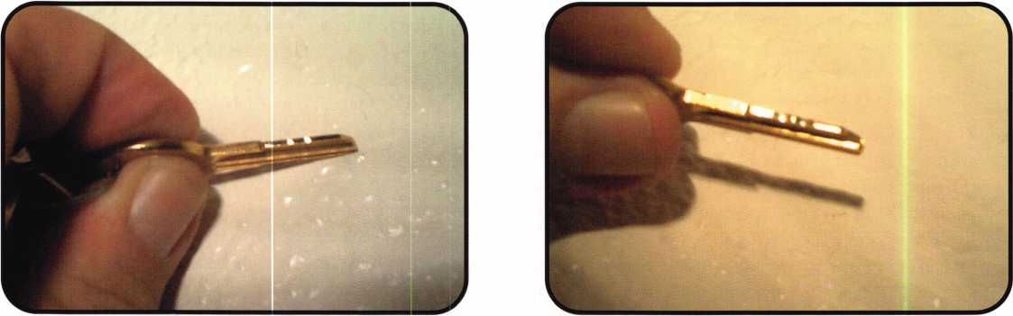

18

19



**SAFE CORPORATION**

MANUFACTURES OF QUALITY DEPOSITORY SAFES AND CHESTS

DISTRIBUTING FROM WAREHOUSES IN

* LOS ANGLES**,** CA
* CHICAGO**,** IL
* GLASSBORO, NJ

A & B is now a stocking distributor

for Mutual Safes  
featuring

H|

AB-4-30-3S AB-9-2

Chose from over 75 models in stock

jjwW

-u



WS 10-2

We ship your order within

24 hours

See us

at *[www.a-bsafecorp.com](http://www.a-bsafecorp.com)*800-253-1267  
Fax 856-863-1208

CALL FOR YOUR  
CATALOG TODAY

**28**

Keynotes • September 2003

**Fastening Solutions**



.. jj |.

.... ■



TECHNICAL SATES, INC.

**Pearl Technical Sales**

***featuring sex bolt solutions from***

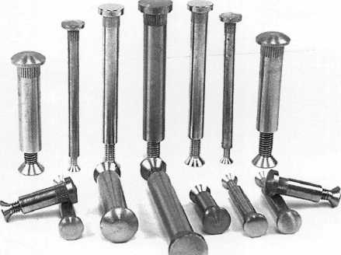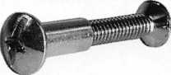

Sex Bolt Hardware and Fasteners - In stock for immediate shipment.

• Sex Bolts - Standard and Custom Sizes • Custom Service

* Sex Bolt Assortment Kits
* Barrel Bolts
* Binding Posts
* Connecting Bolts

50 Piece Minimum custom order  
Quick TurnAround  
CNC manufactured, Top Quality  
Brass, Stainless Steel, and Steel materials  
Architectural finishes

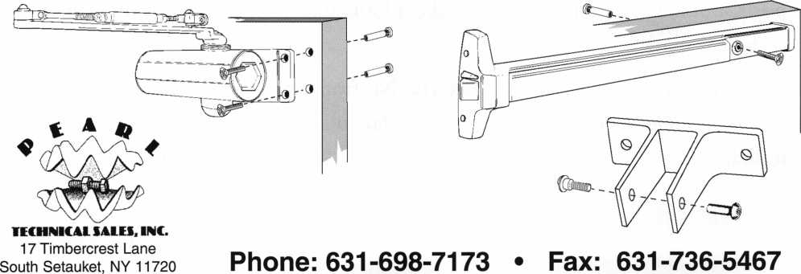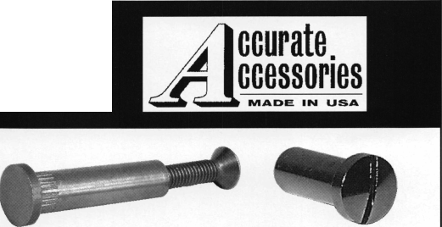

Inside the 2000 Kia Spectra

By Jeff Trepanier, RL

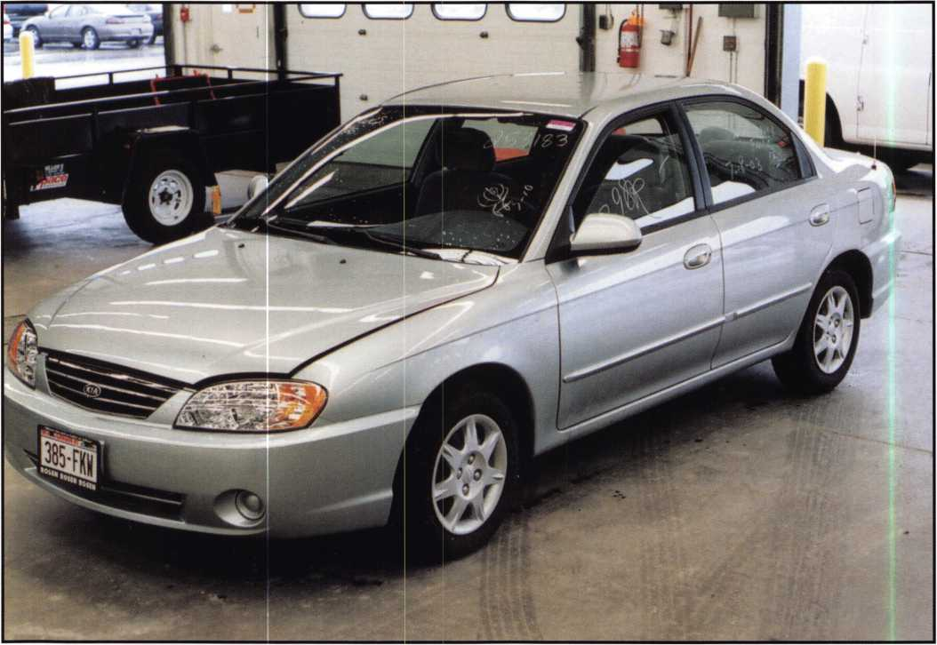

An interesting little sedan, the car is proudly described by its makers as, “a car that looks sporty, but acts responsibly” Let’s take a look and see how responsibly the locks on the car work.

I sight read the key and it looks like 23432112. No transponder in the key This is a Korean-made vehicle. I noticed that the Hyundai and Kia both use the same igni­tion cylinder.



Keynotes • September 2003

1. The key has 8 cuts.

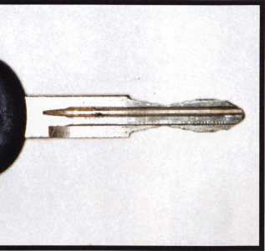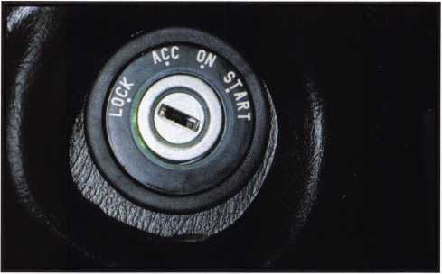

2. To remove the steering column shroud, you need to remove three Philips screws in the lower shroud. Two are at the front of the shroud by the steering wheel, and the third is located near the left rear. Gently unsnap the upper and lower shroud and remove the lower shroud.

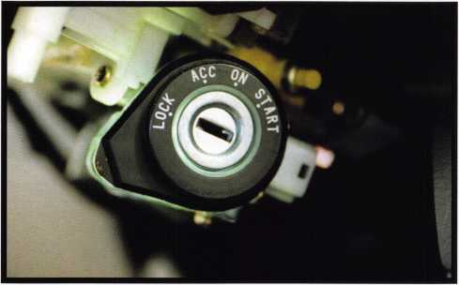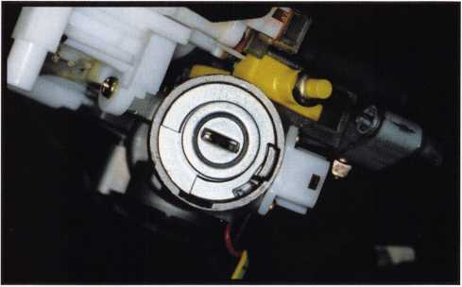

3. The lighted bezel around the ignition cylinder after the lower shroud has been removed. To remove the lighted bezel, remove one Philips screw from underneath, and slide it off.

4. To remove the ignition cylinder, turn the ignition to the ACC position and push in on the active retainer. The retainer is located directly underneath (about the 6 o’clock position) and about 1 1/2 inch housing at the 6 o’clock position. This is to help push in on the active retainer during assembly.

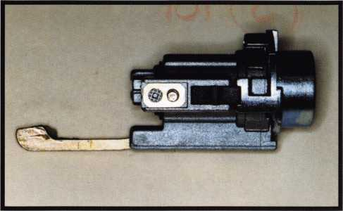

5. The ignition cylinder, removed. If further service is needed, you can disassemble the ignition by gently prying out the rectangular rubber piece to the right of the active retainer and turn the face of the ignition, removing the retainer at the end of the ignition, and push out the plug. Be careful of any spring-loaded parts, and make sure none of the wafers fall out.

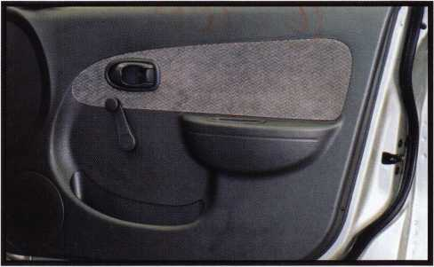

6. Passenger’s front door.

Keynotes • September 2003

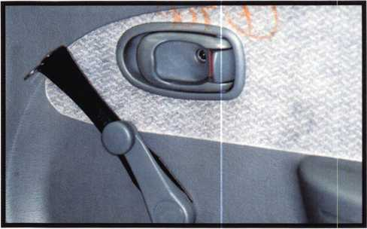

7. The window crank and door release. To remove the door panel, we start by using a specialty tool to remove the clip from the window crank. Insert tool as seen in the photo and push, being careful not to lose the window crank retainer.

All locksmiths should have extra retainers, just in case.

Next, remove the Philips screw from the door handle release cavity. Remove one Philips screw from the door-pull cavity.

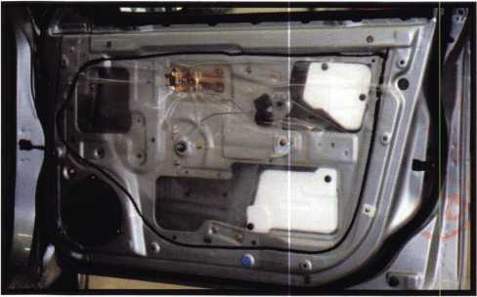

9. Door with panel removed.

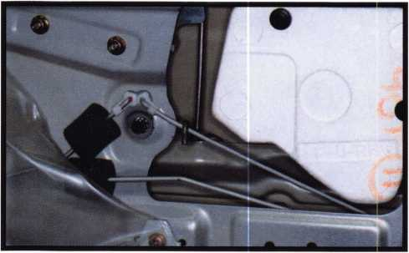

11. The contact point of the opening tool and the lock rod.

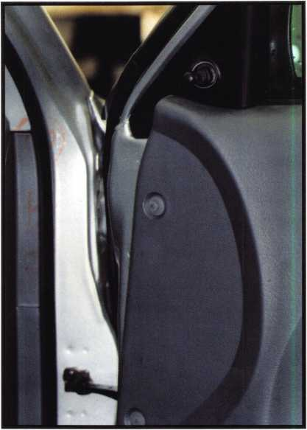

8. The upper front edge of the door. Next, we gently pry (or pull by hand) the trim around the mirror adjusting the lever. Then, remove the plastic two plastic retainers, and then two Philips screws at the bottom edge of the door. One more metal Philips screw is is at the edge of the door at the latch area. Note: Under the front of the door han­dle release trim is a post that helps hold the door panel to the door. Once this is released, you can remove the door panel.

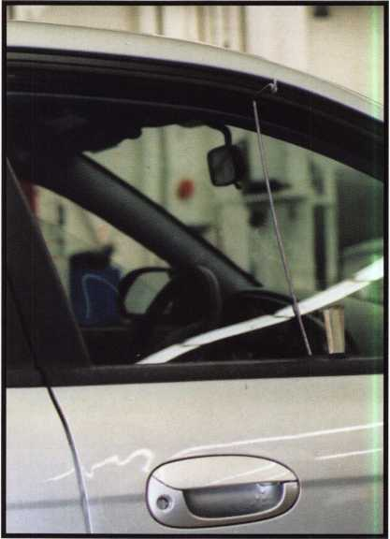

10. The door opening tool in place. To open the locked door, you measure about 14 inches from the edge of the door and go about eight inches down. To unlock, drop down on top of the rod, twist to bind, and move the rod toward the front of the car. (Use the short end of the opening tool.)

Keynotes • September 2003

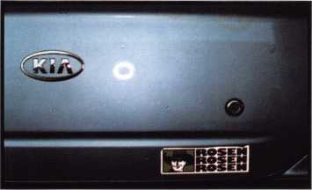

12. The trunk lock. (This vehicle is equipped with a trunk release.)

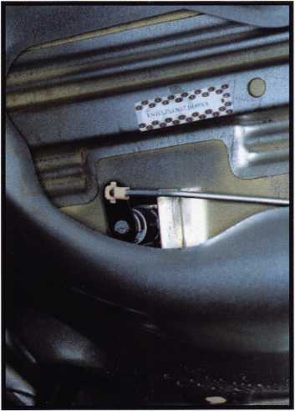

13. The inside of the trunk lock. To remove, start by unclipping the lock rod and then remove the lock retaining clip.

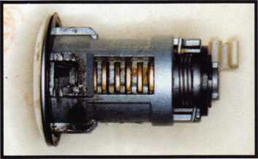

14. The trunk lock, up close. You can see all eight wafers through the drain hole at the bottom of the lock. Turning the lock is needed to see all eight wafers. Once you have the trunk lock out, it should take about 30 minutes or less to make a key, depending on your equipment and code source.

The Ins And Outs Of Secure Locks

Sargent 9200 with Sargent Mogul

AirTeq Mogul

RR Brink Mogul

an ASSA ABLOY Group company

ASSA ABLOY

Southern Steel Mogul

Rim And Mortise Cylinder

Exterior Wall Tube Lock

Norment Mogul

Adtec Mogul

Whether they're standing up to the heaviest usage or providing maximum security, the ASSA mogul cylinder is built to give you complete control over your entire facility. Only ASSA provides protection against all forms of physical attack while patented, geographically exclusive keyways assure each facility a unique keyway and protection from unauthorized key duplication. Our innovation, knowledge and service ensure the highest competence and the highest security. We know all the ins and outs of the lock business.

ASSA*

We Secure The World

ASSA, Inc.

110 Sargent Drive New Haven, CT 06511 (800) 235-7482 Fax (800) 892-3256

ASSA Canada 3475 14th Avenue Markham, Ontario L3R OH4 Canada

[www.assalock.com](http://www.assalock.com)

Keynotes • September 2003

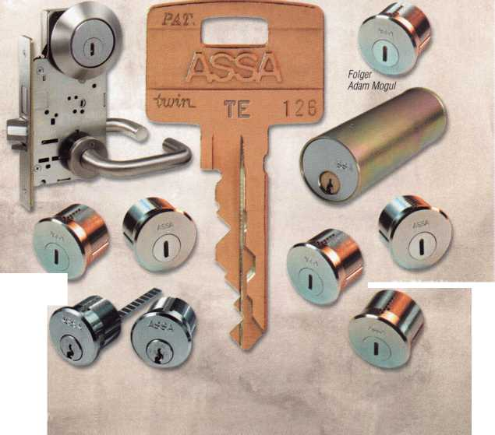

Tuning Up a VINTAGE VICTOR

By Greg Perry, CML. CPS

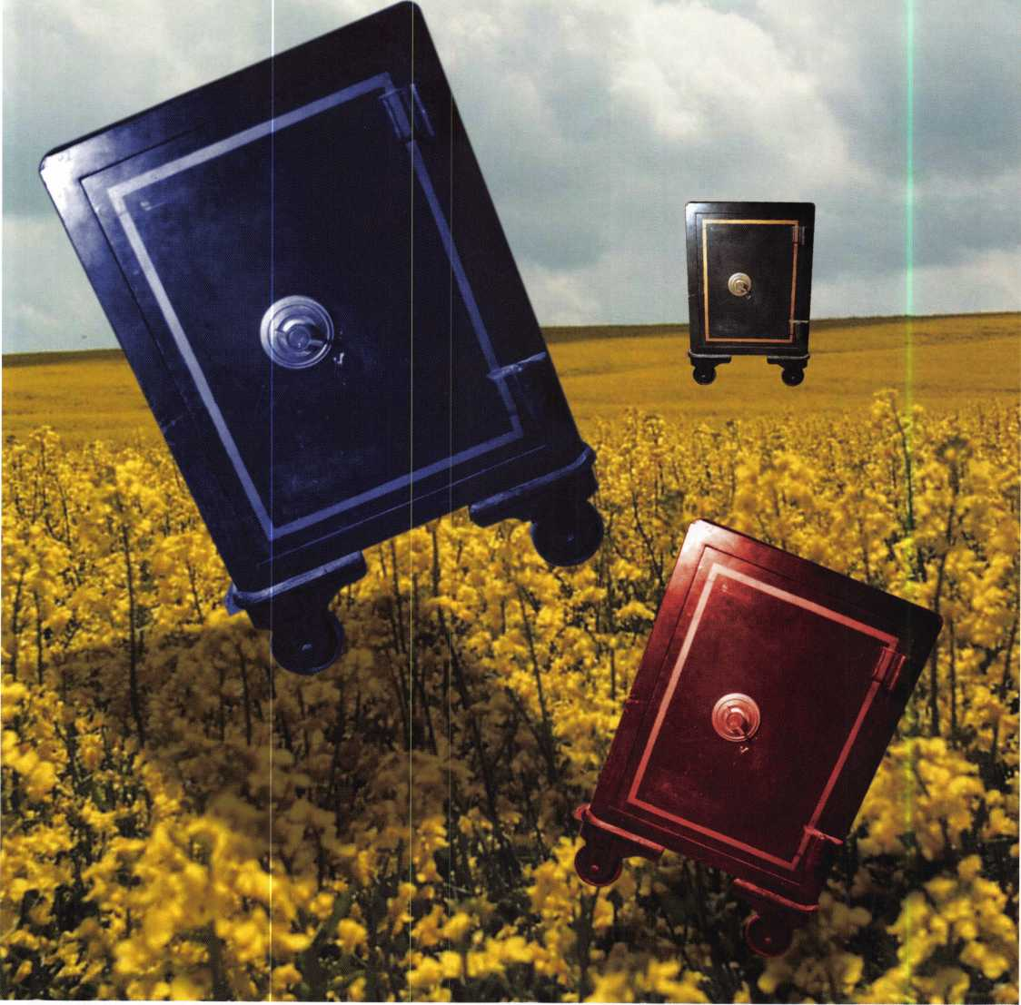

Keynotes • September 2003

Victor Safe Company founded in 1885 was one of the larger cast-iron fire safe companies; they continued to produce safes (according to Carl Cloud) until 1917, when Mosler purchased them. In addition to cast- iron fire safes, they also produced pressed-steel fire safes, cannonballs, jeweler's chests and vault doors. Inside the safes were original guarantee certificates along with service cards that show a picture of the factory with the claim, "The Largest Fire-Proof Safe Works in the World."

The safe shown in this article came  
into our shop for a cleaning and combi-  
nation change. The customer inherited  
it from his grandfather, who he thinks  
was the original owner. Still inside were

the guarantee certificate and an instruction

card suggesting the use of sewing machine oil on the  
"tumblers of the lock" every three months. My first  
thought about the guarantee was that a lawyer wrote  
the document. It left a lot of wiggle room if the safe  
did not protect the contents. I always thought that  
carefully-worded guarantees were a more recent phe-  
nomenon. The wording on the document is "We  
Guarantee Victor Safe No. 214391 to be as fireproof as  
any safe manufactured by any other company; and  
that the materials and workmanship entering into its  
construction are first-class in every respect. In the  
event of fire if the doors are properly closed and  
locked the contents of the safe will be preserved in as  
good condition as they would be in any other safe  
under the same circumstances." I have a feeling prov-  
ing otherwise might be difficult. Also included were

excerpts from a couple of letters attest-  
ing to the fire resistance from two com-  
panies. One was the Pittsburgh Glass  
Company of Cincinnati, Ohio, and the

other from a funeral home whose building

burned in the 1906 San Francisco fire. I'm

guessing our particular safe in question was built  
around 1910. The back of the door has the Victor  
trademark dated 1885.

This safe has no handle; instead, it uses the eared dial to both retract the boltwork and pull the door open. The lock, according to a few other writers, is a model Li lock made by Yale. It has three 2-inch diameter screw changeable wheels and a driver wheel. Wheel one has one screw and wheels two and three have two screws, one on each side. Each wheel has eight threaded holes in them; these can be used to change the combination. The driver has nine larger unthread­ed holes. There is a steel ring with a peg on it used to change the position of where the drive cam picks up the number three wheel. This can also be used to change the combination. I used this method since the



Keynotes • September 2003

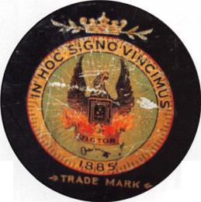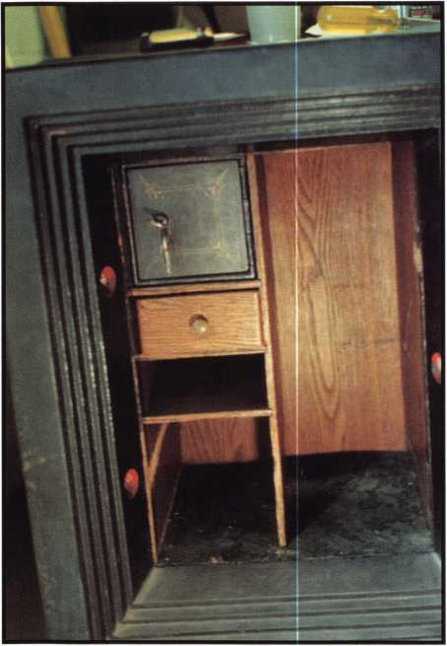

3

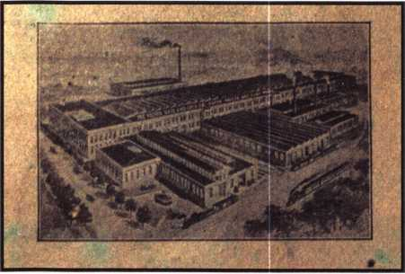

4

6

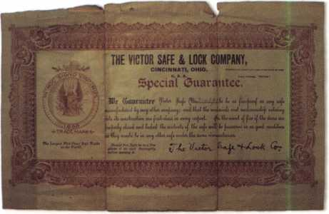

5

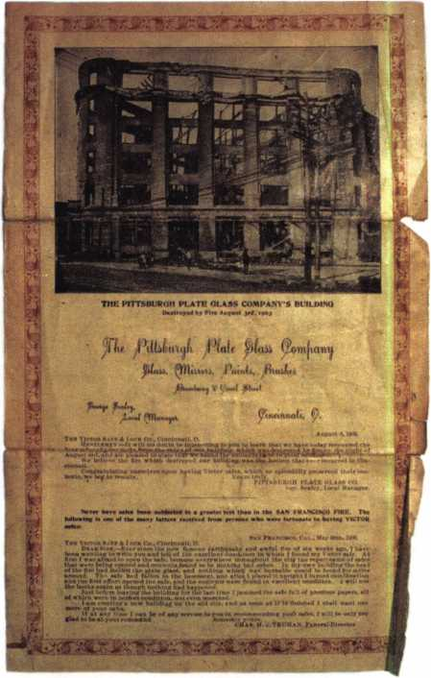

screws in the wheels felt tight and I didn’t want to strip a screw head. The spline key is installed differ­ently than most safe locks. It is placed 90 degrees to the spindle and spans across the drive cam. Looking at the picture, you can see it shaped with a taper on both ends. The key is installed with the taper toward the lock to make removal easier. I use a scribe type probe to pry under the key to remove them. The last piece to go onto the wheel pack is a screwed-on wheel

cover to keep both the spline key and the steel ring in place.

Cleaning this lock is straightforward; disassemble the lock and use a good quality cleaning solution like L&R instrument cleaner and rinse. Once cleaned, I looked around our lock shop for some sewing machine oil. Since I work in a lock shop, I didn’t find any; instead I used GE Versilube.

Manipulation should be your first choice to open a

**36**

Keynotes • September 2003

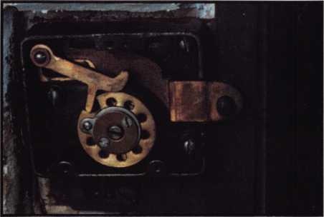

7

locked Victor. Ken Dunckel just wrote a good article in the April, 2003 Boxman on manipulating these locks. Wheel shadowing is a problem. I checked this lock and the lever never touched the drive cam until I parked the wheel gates at drop in. Drilling this safe -- if manipulation fails — should be fairly easy. Place a 1/4-inch hole about 1 3/8 inches to 1 1/2 inches any­where between 75 and 85 on the dial for a great scope hole. If the lock should fail, I would think retrofitting to a current lock would not be difficult. A long bolt or a bolt extension would be needed. As much as I might want to own this lock or one like it for my collection,

I could not in good conscience try to convince a cus­tomer to give up a very functional lock.

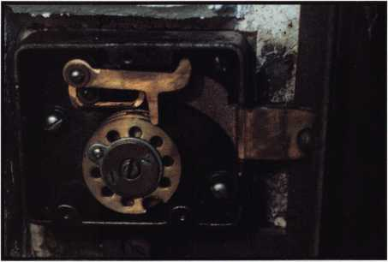

8

Working on these old antiques can be interesting. It's kind of like listening to your grandparents: They offer a completely different perspective. The locks are con­structed very differently from today's locks, and unlike today, the safe manufacturers often produced the locks themselves. Each lock would be produced by hand, and often all the parts were individually numbered. The craftsmanship of that era is simply not seen very often in today's mass-produced world.

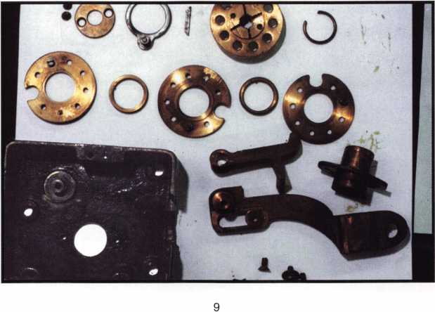

Keynotes • September 2003

3

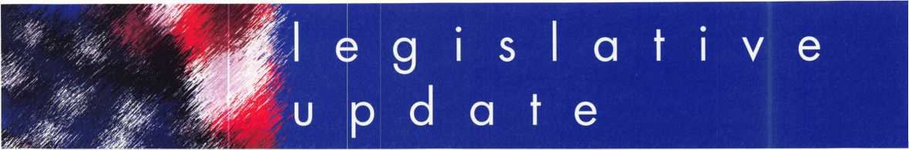

Outlook for Association Health Plan Legislation in Senate Unclear

Six weeks after the House approved the Association Health Plan bill (H.R. 660 - The Small Business Health Fairness Act of 2003) with a strong bipartisan vote, the outlook for the bill (S. 545) in the Senate remains unclear. The Senate recessed for the summer on August 1, 2003, and members of Congress will be spend­ing the month of August working in their district, traveling to foreign nations on official trips, and vacationing. Both the House and the Senate will return to legislative business on September 2, 2003.

During the month of July, the Healthcare Coalition participated in a number of meetings with Senators and their staffs to discuss their potential support for the AHP legislation.

It is apparent from these meetings that many Senators continue to maintain a neutral position on the bill. A number of Senators indicated they are leaning in the direction of supporting the legislation and will be taking a closer look at the bill in the future. In particular, we received positive responses of "leaning towards support" from Senator Craig Thomas (R-WY), Wayne Allard (R-CO) and Conrad Burns (R-MT). Also,

Senator Mary Landrieu (D-LA) is reportedly working on suggested changes to the bill that would enable her to be fully supportive. While we did not gain any formal cosponsors for the bill in the Senate during the month of July, we certainly made some progress with a number of these Senators.

It should be stressed that many Senators have yet to really take a hard look at the AHP legisla­tion, as it has not been a priority issue in the Senate to date. Many Senators and staffers who work on health issues have been focused prima­rily on the Medicare legislation now under con­sideration in a House/Senate conference com­mittee. However, this could change in the future, as Senator Judd Gregg (R-NH), Chairman of the Senate Committee on Health, Education, Labor and Pensions has indicated he will hold a hear­ing on "the uninsured problem" and small busi­ness health concerns sometime this fall (likely in late September or October). The AHP legislation will be a prime topic of discussion at this hear­ing. Also, ALOA is aware that Senate Majority Leader Bill Frist (R-TN) has been considering drafting a health reform bill targeted at the unin-

Keynotes • September 2003

sured problem, and the AHP legislation is under consideration for inclusion in any such package. Senator Frist's staff has had discussions on this potential legislation with Bush Administration offi­cials, who of course have indicated their strong support for the AHP legislation. If Senator Frist does move forward with such legislation this fall, this will certainly elevate the attention paid by Senators to the AHP legislation.

Speaking of the Administration, President Bush did make a reference to the AHP legislation in his weekly radio address of August 2, 2003, when he said that "Congress needs to let small businesses join together to purchase health insur­ance for their employees."

When Congress returns in September, ALOA expects that there will be much more activity in the Senate on the AHP legislation.

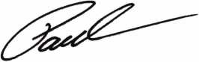

Paul Kanitra

Government Relations Manager

**JOIN THE  
LEGISLATIVE  
ACTION  
NETWORK  
TODAY!**

As we continue to expand our  
resources and become more com-  
petitive in the legislative arena,  
we need the monetary resources  
to match our successes. You can  
help with as little as $24.95 to  
the Legislative Fund. This is only  
the minimum that we are asking,  
and encourage you to give more  
if you can. Those that contribute  
will be given a Legislative Action  
Network Member kit to use in  
their grass roots efforts. Members  
who donate $ 100 or more  
become Legislative Action  
Network Council members, and  
enjoy the following extra benefits:  
a reserved place of distinction on  
the special LAN Council;  
Discounts on ALOA bookstore  
items; 10 % rebate on all ACE  
classes; Complimentary Legislative  
Convention merchandise. Join  
today online at  
[www.aloa.org/news/Ian.htm](http://www.aloa.org/news/Ian.htm).

Keynotes • September 2003



EMPLOYMENT

CENTURION SAFE AND LOCK, INC.

of Cantonsville MD, a thriving community of the out­skirts of Baltimore is forced to close its doors, due to the incapacitation caused by cancer and multiple ret- lated issues of owner, Stephen J. Brown, CML (age 46) (ALOA #8132). Having been unable to generate the necessary funds to keep the more vital bills current, with walk-in traffic only, and the outside road calls virtually impossible for Steve to handle, the need for immediate liquidation has become URGENT. A locksmith shop has occupied this rental storefront location for 40 + years, with Centurion serving the community faithfully since 1985. Steve would prefer to sell his turnkey opportunity in tact and in its entire­ty, but failing to meet his 95K asking price will sell in part if it becomes a final option. The business includes (2) equipped service vans, a 1995 E250 and a 1988 Ford One-ton extended. The fully equipped shop includes all inventory, tools, computer, office supplies, furniture, sidewinder high security key machine, 2 HPC 1200's, Framon #2 and far too much to list here. To speak to Steve, please call 410- 747-5625. -Written for Steve by Gary M Leibman, CRL-ALOA# 17234

LOCKSMITH-SUPERVISOR-INVESTOR

Great opportunity for experienced locksmith to be part of the company. Established and expanding 43- year business in residential, commercial, safes, CCTV, and access control looking for key person to help take us to the next step! Tri-County, Ml. Top pay, med­ical, vacations and bonuses. Fax resume to: 248/969-1398, or call 248/442-2233, or page me direct at 248/908-2277. Large investment - if any - not required! More interested in opportunity-minded person with good locksmith and communication skills. Ask for Mr. Walters!

EXPERIENCED LOCKSMITH WANTED

at established business located in beautiful Marin County, 25 miles from San Francisco. Good pay, health plan, paid absence and pension plan avail­able. Neat appearance and good driving record required. Send resume, refs, to Novato Lock. 7395 Redwood Blvd Novato, CA 94945 or call 415-892-0050

SECURITY TECHNICIAN

Looking for experienced, motivated, hardworking technicians. And team players. Great income poten­tial. Don't delay, send resume today.

Liberty Lock and Safe 5470 W. Sahara Ave.

Las Vegas, NV 89146

Fax 702/876-5470, or [www.libertylock.com](http://www.libertylock.com)

LOCKSMITH WANTED

Work with some of the best in the dynamic and ever­growing Fort Collins - Greeley - Loveland are of Northern Colorado. Present opening is specifically for the Fort Collins area. Must have good driving and clean criminal record. Must be experienced in auto­motive, commercial, residential and safes. Experience in access control and other areas a plus. Advancement commensurate with experienced and performance. Benefit package, including paid vaca­tions, health insurance, retirement and more is avail­able. Please contact:

Raymond D'Adamo, CML • Tri-City Security, Inc.

3517 S. Mason St. • Fort Collins, CO 80525-2616 Cell: 970/566-6517 • Fax: 970/223-4779 E-mail: [rdadamo@mindspring.com](mailto:rdadamo@mindspring.com)

STOP LOOKING!!!!!

EXPERIENCED TECHNICIANS WANTED Lock into your future now!

If you are experienced, intelligent, and desire a secure future, come join our team. We are a full serv­ice commercial/residential security service (locks,keys,safes,cctv,access control, door related hardware). We offer: top wages, company vehicle, 401k, paid vacation, paid holidays, new uniforms, cross training, and job satisfaction. We are looking for the best tech's, who are ready to be treated and compensated as professionals.

Bass Security Services, Inc.

Ph#216-755-1200 ex.#128

Fax#216-755-1220

E-MAIL [rmesnick@bass-security.com](mailto:rmesnick@bass-security.com)

BUSINESS FOR SALE

BUSINESS FOR SALE

Locksmith glass and screen business located in fast growing NW Arizona between Kingman, AZ, and Laughlin, NV. Well-equipped 1995 Dodge van and leased shop on busy highway. All equipment and inventory included. $48,900 takes all. Health demands retirement. Call (928) 565-2294 or e-mail at [lmburks@ctaz.com](mailto:lmburks@ctaz.com).

BUSINESS FOR SALE

Owner Retiring. Well-established business in central Ohio, est. 1965. Sale includes equipment, inventory, 2000 Dodge Ram 2500 van. Commercial and resi­dential accounts. We are a Medeco Patriot dealer for the county and surrounding area. Call 419/562- 4896, or write to: Wink's Lock and Safe • 1 13 W. Warren St. • Bucyrus, OH 44820

FOR SALE

Well-established lock shop, fully-equipped shop van. Hub city, serving all of northeastern Nevada. Same location for 20 years. Large commercial clientele. Great outdoor recreational area, hunting, fishing, etc. Elko Lock and Safe.

Call 775/738-3938, fax 775/738-2370.

BUSINESS FOR SALE

Looking to relocate to sunny Arizona. Established in same location for over 14 years. Profitable Lock & Safe business with service and retail location.

Good client base. Reasonably price to right person. E-mail inquiries to [Lockbizaz@aol.com](mailto:Lockbizaz@aol.com) or fax to (602) 870-8505.

BUSINESS FOR SALE

Mobile locksmith business for sale. Complete. $22K. Van, tools, inventory, books, software, laptop, etc. 305/743-8734.

LOCKSMITH FRANCHISE AVAILABLE

Low cost, complete training, national Franchise call (925) 260-7373 [www.SpeedyLocksmiths.com](http://www.SpeedyLocksmiths.com) . Business For Sale

NORTHERN CALIFORNIA, SAN FRANCISCO BAY AREA, GREAT SALES, FOR MORE INFO CALL (925)260-7373

Classified Advertising Policy

Classified advertising space is provided free of charge to ALOA members, and for a fee of $.60 per word, $ 15 minimum for non-members. Classified ads may be used to advertise used  
merchandise and overstocked items for sale, "wanted to buy" items, business opportunities, employment opportunities/positions wanted and the like. Members or non-members wishing to  
advertise services or new merchandise for sale may purchase a "Commercial Classified Ad," for a fee of $1.30 per word, with a minimum of $40. Each ad will run for two issues. For  
blind boxes there is a $5 charge to members and non-members. All ads must be submitted in writing to the ALOA office by the fifteenth of the month, two months prior to issue date. Send

S

tes Classifieds, 3003 Live Oak St., Dallas TX 75204-6186. ALOA reserves the right to refuse any classified advertisement that it deems inappropriate according to the stated pur-  
pose of the classified advertising section.

Keynotes • September 2003

WANTED TO BUY/SELL

FOR SALE

Full set of HPC general codebooks updated for 2002. Full set of HPC foreign auto codebooks updated to 2002. Both sets for $250, no splits. Future dates available. 508/693-5625.

SHOP IN LOTS

For sale in lots only - key machines, pinning trays, tools, lockout tool sets, merchandise, and collectibles. We pay the freight/shipping. Call or e-mail for com­plete list of items and prices. Call 307/856-0325, or e-mail, [mbarham@wyoming.com](mailto:mbarham@wyoming.com).

FOR SALE

Owner retiring. Lift a Load trailer. 10,000 lbs. Capacity. Excellent condition. Sonny Lee. 770/920-8019.

FOR SALE

Original Schlage blanks in 5-pin EF keyway or 6-pin in CE, EF, FG or G keyway at $12.50 per box of 50. Contact George Thomas at 218-724-3416 or write to 825 Woodlandd Ave., Duluth MN 55812-2168

FOR SALE

Overstock, New Von Duprin 33NL-OP, 33EO, E99K, 3347EO, 9947EO, CD3347TL, EPT-10, Von Duprin electric strike 6211, 6233. Rixson mag hold 980,997 Locknetics 505. Please call for price. Kevin at 915-553-3145, or e-mail reddog2501 @excite.com.

WHOLESALE SAFE DEPOSIT LOCKS Allied, Diebold, Herrin, Hall & Mavin, llco, Lefabure, Mosler, Precission, S&G, Security Corp., Yale. Locks from early 1900s to current. Call or email for lock type and pricing sheet. Quantity discounts. Call WBI at (954)484-2404 or email: [sales@wbi.us](mailto:sales@wbi.us)

CLASS

Ohio Valley chapter of ALOA is holding a safe open­ing class on September 27/28 in Dayton, Ohio. This is an hands-on class and if you have any safes you'd like opened bring them with you. Thanks to help from Lockmasters, all the proceeds from this class will go towards a fundraiser for sending locksmiths to the 2004 ALOA convention and classes. The fee for this two day class is $1 10.00 for ALOA and POLA mem­bers and $150.00 for all others. Please contact Mehdi at (937) 294-4241 for further information. Class is limited to 25 people, so hurry!

Hole Saw  
I Alignment  
Guides

No More Plywood, "C” damps, or Jigs  
Needed to Over Bote Existing Holes

* Our Guides let you over bore existing holes  
  that meas. 5/8”, 3/4" & 1-1/2" diameter
* They work on wood as well as metal
* Ttoo small sizes ideal for desks and cabinets
* Purchase in sets or individually
* Visa, MC, Amex, Discover
* MONEY-RACK GUARANTEE

**'Tri-City Lock Company**

Daniel D. Mello, Owner-Locksmith  
Groveland, CA

209 962 4692 • 209 962 4910 FAX  
E-mail: [slmello@mlode.com](mailto:slmello@mlode.com)

**www.tricitylock. com**

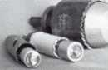

**THE HINGE DOCTOR**

by GKL Products

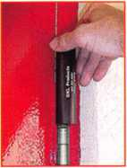

**HA1 For  
Standard**

**Commercial**

**4-1/2" x 4-1/2’**

**Butt Hinges**

**HA2**

***"The HULK***

**For Residential**

COMING IN  
SEPTEMBER

**HA3**

**For Ball-**

**Bearing &**

**Commercial Hinges**

**The Hinge Doctor is a great way to repair those sagging metal  
doors. Slip the tool over the hinge and open the door an inch**

**or two past the point where the tool binds against the  
hinge, remove the tool and check the door,**

**which should now be working properly.**

**If you're a locksmith these tools  
will turn a profit the 1st time you  
use them!  
Uses - schools, hospitals,**

**commercial buildings, storefronts  
with butt hinges, office doors, new**

**construction, door alignment, sagging**

**doors, jail cells, anywhere there are  
commercial grade hinges.**

**HA4**

**For Prison  
& Institutions**

**Hinges &**

**Spring Hinges**

Over

10,000

Satisfied

Customers

US Patent

#6450003

[www.hingedoctor.com](http://www.hingedoctor.com)

800-924-5397

Keynotes • September 2003

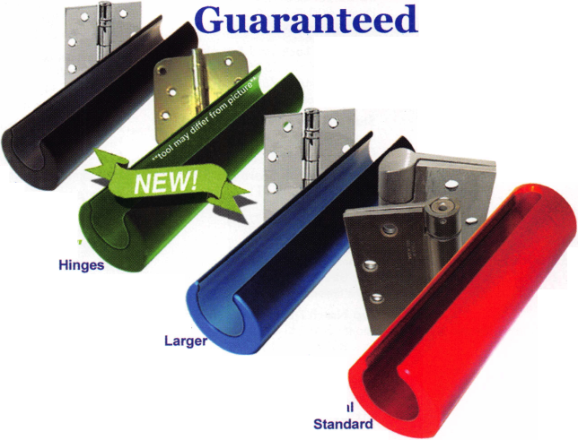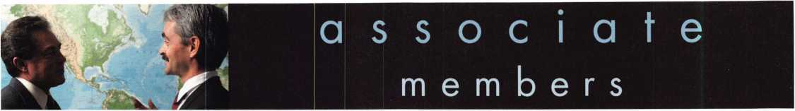

Distributor

ADI Inc

Phone: 631-692-1000 Fax: 631-692-3011

Accredited Lock Supply Co

Phone: 201-865-5015 Fax: 201-865-0030 [www.acclock.com](http://www.acclock.com)

Ace Lock & Security Supply

Phone: 908-688-7666 Fax: 908-688-2442 [www.acelock.com](http://www.acelock.com)

Andrews Wholesale Lock Supply

Phone: 717-272-7422 Fax: 717-274-8659 [www.andrewslock.com](http://www.andrewslock.com)

Boyle & Chase Inc

Phone: 800-325-2530 Fax: 800-205-3500 [www.boyleandchase.com](http://www.boyleandchase.com)

Chinrose International

Phone: 503-357-7553 Fax: 503-357-5522 [www.chinrose.com](http://www.chinrose.com)

Clark Security Products

Phone: 800-854-2088 Fax: 619-974-5284 [www.clarksecurity.com](http://www.clarksecurity.com)

Cook's Building Specialties

Phone: 505-883-5701 Fax: 505-883-5704

Dire's Lock & Key Company

Phone: 303-294-0176 Fax: 303-294-0198

Direct Security Supply; Inc.

Phone: 800-252-5757 Fax: 800-452-8600

Doyle Security Products

Phone: 800-333-6953 Fax: 612-521-0166 [www.doylesecurity.com](http://www.doylesecurity.com)

Dugmore and Duncan, Inc.

Phone: 888-384-6673 Fax: 888-329-3846

E. L. Reinhardt Co., Inc.

Phone: 800-328-1311 Fax: 651-481-0166 [www.elreinhardt.com](http://www.elreinhardt.com)

Ewert Wholesale Hardware

Phone: 800-451-0200 Fax: 708-597-0881

Fairway Supply, Inc.

Phone: 214-350-0021 Fax: 214-352-4299 [www.fairwaysupply.com](http://www.fairwaysupply.com)

Foley-Belsaw Company

Phone: 800-821-3452 Fax: 816-483-5010 [www.foley-belsaw.com](http://www.foley-belsaw.com)

Fried Brothers Inc.

Phone: 800-523-2924 Fax: 215-592-1255 [www.fbisecurity.com](http://www.fbisecurity.com)

H L Flake Co

Phone: 800-231-4105 Fax: 713-926-3399 [www.hlflake.com](http://www.hlflake.com)

H.S. & S. Wholesale Distrib.

Phone: 313-342-6777 Fax: 313-342-7580

Hans Johnsen Company

Phone: 214-879-1550 Fax: 214-879-1530 [www.hjc.com](http://www.hjc.com)

Hardware Agencies, Ltd.

Phone: 416-462-1921 [www.hardwareagencies.com](http://www.hardwareagencies.com)

IDN Incorporated

Phone: 817-421-5470 Fax: 817-421-5468 [www.idn-inc.com](http://www.idn-inc.com)

Intermountain Lock & Supply

Phone: 800-453-5386 Fax: 801-485-7205 [www.intermountainlock.com](http://www.intermountainlock.com)

Jo Van Distributors

Phone: 416-752-2238 Fax: 416-752-7282 [www.jovanlock.com](http://www.jovanlock.com)

KeylessRide

Phone: 877-619-3136 Fax: 409-216-5058 [www.keylessride.com](http://www.keylessride.com)

Lockmasters, Inc.

Phone: 859-885-6041 Fax: 859-885-7093 [www.lockmasters.com](http://www.lockmasters.com)

Locks Company

Phone: 800-288-0801 Fax: 305-949-3619

Locksmith Ledger International

Phone: 770-886-0800 Fax: 770-889-7703 [www.lledger.com](http://www.lledger.com)

M. Zion Company

Phone: 212-349-8677 Fax: 212-964-0495 [www.mzion.com](http://www.mzion.com)

McDonald Dash Locksmith Supply

Phone: 800-238-7541 Fax: 901-366-0005 [www.mcdonalddash.com](http://www.mcdonalddash.com)

McManus Locksmith Supply, Inc

Phone: 704-333-9112 Fax: 704-332-8664

Monaco Lock Co.

Phone: 800-526-6094 Fax: 800-845-5625 [www.monacolock.com](http://www.monacolock.com)

Omaha Wholesale Hardware

Phone: 800-238-4566 Fax: 402-444-1664 [www.omahawh.com](http://www.omahawh.com)

Phoenix Safe International LLC

Phone: 765-483-0954 Fax: 765-483-0962 www. phoen ixsafeusa .corn

Professional Business Products

Phone: 248-360-3979

Fax: 248-360-3982

[www.professionalbusinessproducts](http://www.professionalbusinessproducts).

RA-Lock Company

Phone: 972-775-6301 Fax: 972-775-6316 [www.ralock.com](http://www.ralock.com)

S J Hope Products

Phone: 702-260-7645 Fax: 702-837-1465

SNA Inc.

Phone: 678-206-0381 Fax: 678-206-0382 [www.sungil-safe.com](http://www.sungil-safe.com)

SecureRite.Com

Phone: 800-241-3930 Fax: 858-974-5269 [www.SecureRite.Corn](http://www.SecureRite.Corn)

Security House

Phone: 905-669-5300 Fax: 905-660-6313 [www.securityhouselock.com](http://www.securityhouselock.com)

Security Lock Distributors

Phone: 800-847-5625 Fax: 800-878-6400 [www.securadealer.com](http://www.securadealer.com)

Sentry Security Fasteners

Phone: 309-693-2800 Fax: 800-693-2872

Somerset Security Products

Phone: 800-881-5206 Fax: 800-206-9949

Southern Lock and Supply Co.

Phone: 727-541-5536 Fax: 727-544-8278 [www.southernlock.com](http://www.southernlock.com)

Stone & Berg Wholesale

Phone: 800-225-7405 Fax: 800-535-5625

The Locksmith Store Inc.

Phone: 847-364-5111 Fax: 847-364-5125 [www.locksmithstore.com](http://www.locksmithstore.com)

Timemaster Inc

Phone: 859-259-1878 Fax: 859-255-0298 [www.ti](http://www.ti) me-master.com

Top Notch Distributors, Inc.

Phone: 800-233-4210 Fax: 800-854-4146 [www.4topnotch.com](http://www.4topnotch.com)

Turn 10 Wholesale

Phone: 800-848-9790 Fax: 800-391-4553

U.S. Lock Corp.

Phone: 800-925-5000 Fax: 800-338-5625 [www.uslock.com](http://www.uslock.com)

Wilco Supply

Phone: 800-745-5450 Fax: 510-653-5397 [www.wilcosupply.com](http://www.wilcosupply.com)

Manufacturer

A & B Safe Corporation

Phone: 800-253-1267 Fax: 856-863-1208 [www.a-bsafecorp.com](http://www.a-bsafecorp.com)

ABUS Lock Company

Phone: 800-352-2287 Fax: 602-516-9934 [www.abus.com](http://www.abus.com)

Abloy Door Security

Phone: 800-465-5761 Fax: 514-335-0430 [www.abloy.com](http://www.abloy.com)

Adams Rite Mfg Company

Phone: 800-872-3267 Fax: 800-232-7329 [www.adamsrite.com](http://www.adamsrite.com)

Adesco Safe Mfg. Company

Phone: 800-694-9340 Fax: 562-408-6427 [www.adesco.com](http://www.adesco.com)

Adrian Steel Company

Phone: 800-677-2726 Fax: 517-265-5834 [www.adriansteel.com](http://www.adriansteel.com)

Alarm Lock Systems Inc.

Phone: 800-252-5625 Fax: 516-789-3383 [www.alarmlock.com](http://www.alarmlock.com)

All Five Tool Company, Inc.

Phone: 860-583-1691 Fax: 860-583-4516 [www.all5tool.com](http://www.all5tool.com)

American Lock Company

Phone: 708-534-2000 Fax: 708-534-0531 [www.armericanlock.com](http://www.armericanlock.com)

American Security Products

Phone: 909-685-9680X1083 Fax: 909-685-9685 [www.amsecusa.com](http://www.amsecusa.com)

BWD Automotive

Phone: 334-872-6524 Fax: 334-874-6011 [www.bwdautomotive.com](http://www.bwdautomotive.com)

Baldwin Hardware

Phone: 610-796-4012 Fax: 610-796-4493 [www.baldwinhardware.com](http://www.baldwinhardware.com)

Be-Tech Security Systems Ltd

Phone: 852-231-67447 [www.be-tech.com.hk](http://www.be-tech.com.hk)

Bianchi USA, Inc.

Phone: 800-891-2118 Fax: 216-803-0202

Buddy Products

Phone: 800-886-8688 Fax: 312-733-8356 [www.buddyproducts.com](http://www.buddyproducts.com)

CCL Security Products

Phone: 800-733-8588 Fax: 847-537-1800

COMPX Security Products

Phone: 864-297-6655 Fax: 864-297-9987 [www.nclnet.com](http://www.nclnet.com)

Keynotes • September 2003

|  |  |  |
| --- | --- | --- |
| a | s s o c i a 1 | t e |
|  | members |  |

Curtis Industries, A Barnes Distr

Phone: 800-555-5397 Fax: 800-867-6020 [www.curtisindustries.com](http://www.curtisindustries.com)

D&D Technologies (USA), Inc

Phone: 714-677-1300X292 Fax: 714-677-1299 [www.ddtechusa.com](http://www.ddtechusa.com)

DETEX Corporation

Phone: 800-729-3839 Fax: 830-620-6711 [www.detex.com](http://www.detex.com)

DORMA Architectural Hardware

Phone: 717-336-3881 Fax: 717-336-3500 [www.dorma-usa.com](http://www.dorma-usa.com)

Datakey Electronics

Phone: 800-328-8828 Fax: 866-289-4212 [www.datakeyelectrnics.com](http://www.datakeyelectrnics.com)

Don-Jo Manufacturing, Inc.

Phone: 978-422-3213 Fax: 978-422-3467 [www.don-jo.com](http://www.don-jo.com)

Door Controls International

Phone: 800-742-3634 Fax: 800-742-0410 [www.doorcontrols.com](http://www.doorcontrols.com)

ESP Lock Products Inc.

Phone: 978-562-3481 Fax: 978-562-9859

FireKing Security Products

Phone: 800-457-2424 Fax: 800-896-6606 [www.fireking.com](http://www.fireking.com)

HES, Inc

Phone: 623-582-4626 Fax: 623-582-4641 [www.hesinnovations.com](http://www.hesinnovations.com)

HPC, Inc.

Phone: 847-671-6280 Fax: 847-671-6343 [www.hpcworld.com](http://www.hpcworld.com)

HY-KO Products Co.

Phone: 440-232-8223X3095 Fax: 440-232-8227

Hongtai Lock Co Ltd

Phone: 137-238-1414 Fax: 208-793-3856

INTELLIKEY Corp.

Phone: 800-226-0703 Fax: 321-724-0811 [www.intellikey.com](http://www.intellikey.com)

Jet Hardware Mfg., Co.

Phone: 718-257-9600 Fax: 71 8-257-0973 www. j etkeys. com

KABA High Security Locks

Phone: 860-621-3601 Fax: 860-621-9727 [www.kabausa.com](http://www.kabausa.com)

KABA ILCO Corp.

Phone: 252-446-3321 Fax: 252-446-4702 [www.kaba-ilco.com](http://www.kaba-ilco.com)

KEY-BAK/West Coast Chain Mfg

Phone: 909-923-7800 Fax: 909-923-0024 www. key ba k. com

Keri Systems Inc

Phone: 408-451-2520 Fax: 408-441-0309 [www.kerisys.com](http://www.kerisys.com)

Knaack Manufacturing Co.

Phone: 800-456-7865 Fax: 815-459-9097 [www.weatherguard.com](http://www.weatherguard.com)

LAB Security

Phone: 800-243-8242 Fax: 860-583-7838 [www.labpins.com](http://www.labpins.com)

LCN Closers/Div of Ingersoll

Phone: 815-875-3311 Fax: 815-879-1497 [www.lcnclosers.com](http://www.lcnclosers.com)

La Gard Inc.

Phone: 310-325-5670 Fax: 310-325-5615 [www.lagard.com](http://www.lagard.com)

Lock America, Inc. Dba L.A.I. Gro

Phone: 714-373-2993 Fax: 714-373-2998 [www.laigroup.com](http://www.laigroup.com)

Lucky Line Products, Inc.

Phone: 858-549-6699 Fax: 858-549-3241 [www.luckyline.com](http://www.luckyline.com)

M.A.G. Security

Phone: 714-891-5100 Fax: 714-892-6845 [www.magsecurity.com](http://www.magsecurity.com)

MARKS, U.S.A.

Phone: 516-225-5400 Fax: 516-225-6136 [www.marksusa.com](http://www.marksusa.com)

MARRAY ENTERPRISES

Phone: 408-970-0213 Fax: 408-970-8767 [www.marray.com](http://www.marray.com)

MCS Communication Systems

Phone: 450-444-2040X225 Fax: 450-444-4856 [www.mcscommunication.com](http://www.mcscommunication.com)

MMD, Inc.

Phone: 865-428-3611 Fax: 865-453-4136

MUL-T-LOCK USA, Inc

Phone: 800-562-3511 Fax: 973-778-4007 www. m u l-t-l oc k. co m

Master Lock Company

Phone: 414-444-2800 Fax:414-444-0322 [www.masterlock.com](http://www.masterlock.com)

Medeco Security Locks

Phone: 540-380-5000 Fax: 540-380-5010 [www.medeco.com](http://www.medeco.com)

Mustang Company

Phone: 574-674-0053 Fax: 574-675-9603

NKL Industries Inc

Phone: 800-528-9900 Fax: 757-485-0271 [www.nklindustries.com/products_NK](http://www.nklindustries.com/products_NK)

OSI Security Devices

Phone: 619-628-1000 Fax: 619-628-1001 [www.omnilock.com](http://www.omnilock.com)

Pro Steel

Phone: 801-373-2385 Fax: 801-373-2399 [www.prosteel.us](http://www.prosteel.us)

ROFU International Corp

Phone: 800-255-7638 Fax: 253-922-1728 [www.rofu.com](http://www.rofu.com)

Rutherford Controls Int'l Co

Phone: 757-427-1230 Fax: 757-427-9549 [www.rutherfordcontrols.com](http://www.rutherfordcontrols.com)

STRATTEC Security Corp.

Phone: 414-247-3415 Fax: 414-247-3692 [www.strattec.com](http://www.strattec.com)

Sargent & Greenleaf, Inc.

Phone: 859-885-9411 Fax: 859-885-3063 [www.sargentandgreenleaf.com](http://www.sargentandgreenleaf.com)

Sargent Manufacturing Co

Phone: 203-562-2151 Fax: 203-776-5992 [www.sargentlock.com](http://www.sargentlock.com)

Schlage Lock Co

Phone: 719-264-5300 Fax: 719-264-5382 [www.schlagelock.com](http://www.schlagelock.com)

Schwab Corp

Phone: 765-447-9470 Fax: 765-447-8278 [www.schwabcorp.com](http://www.schwabcorp.com)

Secure-UR-Home

Phone: 905-771-7300 Fax: 905-771-7304

Securitron Magnalock Corp.

Phone: 775-355-5625 Fax: 775-355-5636 [www.securitron.com](http://www.securitron.com)

Security Door Controls

Phone: 805-494-0622 Fax: 805-494-8861 [www.sdcsecurity.com](http://www.sdcsecurity.com)

Security Solutions

Phone: 405-376-1600 Fax: 405-376-6870

[www.securitysolutions-usa.com](http://www.securitysolutions-usa.com)

Sully Tools Inc

Phone: 703-689-3416 Fax: 703-787-0869 [www.sullytools.com](http://www.sullytools.com)

Sun Safes Manufacturing Co.

Phone: 823-194-59300 Fax: 823-194-59400 [www.eaglesafes.com](http://www.eaglesafes.com)

Taylor Security & Lock

Phone: 301-948-7670 Fax: 301-948-1029 [www.taylorsecurity.com](http://www.taylorsecurity.com)

Taymor Industries, Inc.

Phone: 800-388-9887 Fax: 800-288-8133

Townsteel, Inc.

Phone: 626-858-5080 Fax: 626-858-3393

Trine Access Technology

Phone: 718-829-2332 Fax: 718-829-6405 [www.trineonline.com](http://www.trineonline.com)

Victor E-lok, Inc

Phone: 949-916-1200 Fax: 949-916-1300 [www.victorelok.com](http://www.victorelok.com)

Videx Inc

Phone: 541-758-0521 Fax: 541-752-5285 [www.videx.com](http://www.videx.com)

W-LOK Corporation

Phone: 616-355-4015 Fax: 616-355-4295 [www.wlokcorp.com](http://www.wlokcorp.com)

YSG Door Security Consultants, In

Phone: 800-438-1951 Fax: 800-338-0965

Service Organization

1 -800 Locksmith 1994 Inc

Phone: 800-562-5764 Fax: 718-236-4504 www. 1 800locksmith.net

Allstate Insurance Company

Phone: 800-859-0247 Fax: 847-326-7509 [www.allstate.com](http://www.allstate.com)

Cross Country Automotive Services

Phone: 800-541-2262 Fax: 781-393-0256 [www.argosi.com](http://www.argosi.com)

Emergency Road Service Inc

Phone: 888-839-5386 Fax: 678-277-8105

Massglass & Door Service

Phone: 888-742-8837 Fax: 805-497-2255

[www.massglass.com](http://www.massglass.com)

The National Locksmith

Phone: 630-837-2044 Fax: 630-837-1210 [www.thenationallocksmith.com](http://www.thenationallocksmith.com)

The Security Professionals

Phone: 866-486-1938

Fax: 856-486-0401

[www.thesecurityprofessionals.com](http://www.thesecurityprofessionals.com)

Webster Safe & Lock Co., Inc

Phone: 901-332-2911 Fax: 901-332-2878 [www.webstersinc.com](http://www.webstersinc.com)

Keynotes • September 2003

back page

About the Authors

Jim Hancock, CRL, began his locksmithing career at the age of 8 in his grandfathers lock shop in Gulfport, Mississippi. He has been work­ing as a locksmith since 1974. He currently is the manager of Cothron’s Lock & Safe and the lead instructor of Cothron’s School of Professional Locksmithing in Austin, Texas. Jim has taught for many regional associations and is an ALOA Certified Instructor who teaches at ALOA conventions and at ACE classes throughout the country.

Greg Perry, CML, CPS, has been in the locksmith industry for 20 years. He’s spent half of that time as a field technician for Security Engineering in Ridgecrest, CA. Greg is also a past president of the Desert Counties Chapter of the California Locksmiths Association. He has also won the 2002 Keynotes Author of the Year Award. You can e-mail him at [glmperry@iwvisp.com](mailto:glmperry@iwvisp.com).

Jeff Trepanier, RL, owns and operates Interstate Lock Masters in Racine, Wl. He has been published in several trade magazines and is widely recognized as an automotive locksmithing guru.

|  |  |
| --- | --- |
| Stam | 3 |
| DHI | 7 |
| Turn 10 | 9 |
| Fox Valley Technical Col! | lege 9 |
| SNA | 15 |
| A&B Safe 28, Back Page | |
| Pearl Technical Sales/ Accurate Accessories | 29 |
| Assa | 33 |
| Hinge Doctor | 41 |
| Tri-City Lock Co | 41 |
| Medeco Inside Back Cover | |
| Hickok Back Cover | |
| Ad Index | |
| L | J |

New Product



**SAFE CORPORATION Viking Stainless**

Fire & Burglary Protection  
State of the Art Composite Fill

Strong • Functional • Attractive

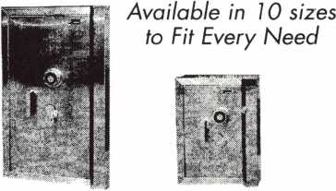

See us at [www.a-bsafecorp.com](http://www.a-bsafecorp.com)

1*-*800*-*253-1267

Fax 856-863-1208

CALL FOR YOUR CATALOG TODAY

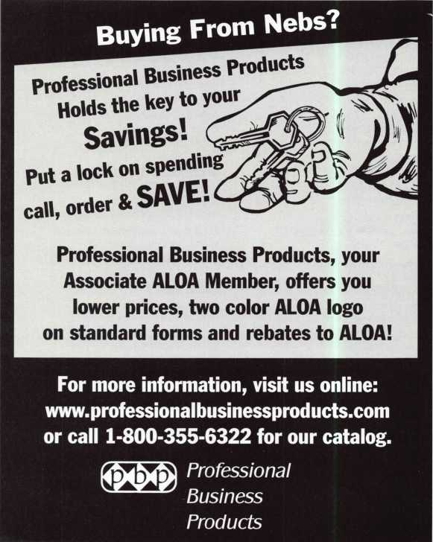

Keynotes • September 2003

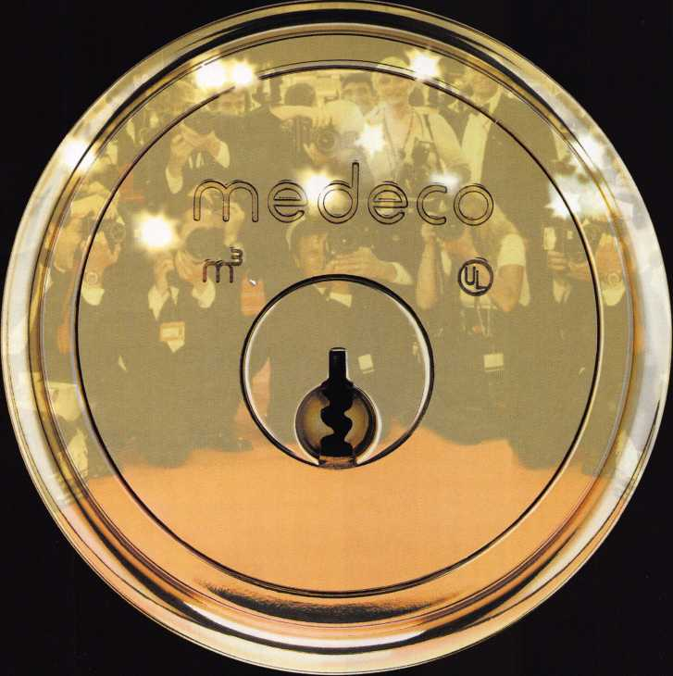

**MEDECO RECENTLY GOT CALLED ON THE CARPET. THE RED CARPET.**

medeco DEBUTS with rave reviews, and record-breaking sales.

WE'D LIKE TO TAKE THIS OPPORTUNITY TO THANK ALL THOSE WHO MADE ITS SUCCESS POSSIBLE: Distributors and locksmiths who were amazed we could create a patented locking system better than Biaxial.

The competition who thought we’d let up, content to be number one.

The customers who demanded the same physical strength and key control but with expanded master key capacity.

The Medeco engineers who believed two locking mechanisms weren’t enough.

To all of you who gave us suggestions, we say thanks. We couldn’t have done it without you.

**medeco**

**P.O. Box 3075, Salem, Virginia 24153-0330 I Customer Service: 1-800-839-3157 I [www.medeco.com](http://www.medeco.com) high security locks**

**© 2003, Medeco Security Locks. Inc.**

**You're never on your own..**

**Toll Free Tech Support**

1-800-342-5080

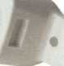

I've lost my Taurus keys...  
can you make a new set?"

How much of your money  
have you sent to the  
local Ford dealer?

8008LA New Generation STAR

Use the Ford factory tool to  
program transponder keys for  
ALL Ford/Mazda vehicles.

Keep the money in your pocket!

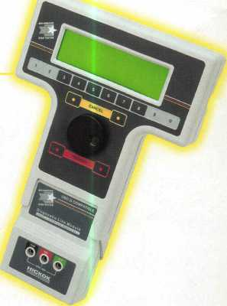

NGS

Complete  
Ford/Mazda  
transponder  
coverage

PLUS the

ability to  
clear ALL  
Diagnostic

Service Codes

Say "YES" to  
$100 phone calls



HICKOK

INCORPORATED

